# EXPERIMENT NO-1

Aim – Installation of R and R studio

Theory-

R is a language and environment for statistical computing and graphics. R provides a wide variety of statistical (linear and nonlinear modelling, classical statistical tests, time-series analysis, classification, clustering, …) and graphical techniques, and is highly extensible.

Steps to install R and R Studio on Ubuntu 18.04

Step 1- Update the system.

Command-sudo apt-get update, sudo apt -y upgrade Step 2- Install R on ubuntu.

Command- sudo apt -y install r-base Step 3- Download and install R Studio Commands-

wget <https://download1.rstudio.org/desktop/bionic/amd64/rstudio-1.2.1578-amd64.deb>

sudo dpkg -i rstudio-1.2.1578-amd64.deb

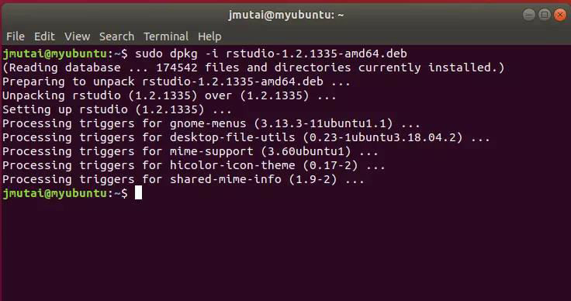

Step 4- Launch R on terminal

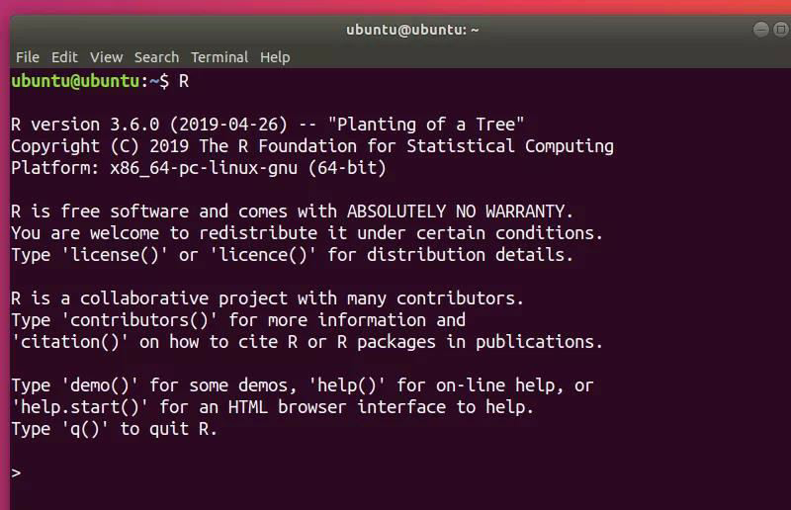

Step 5 – Launch R studio

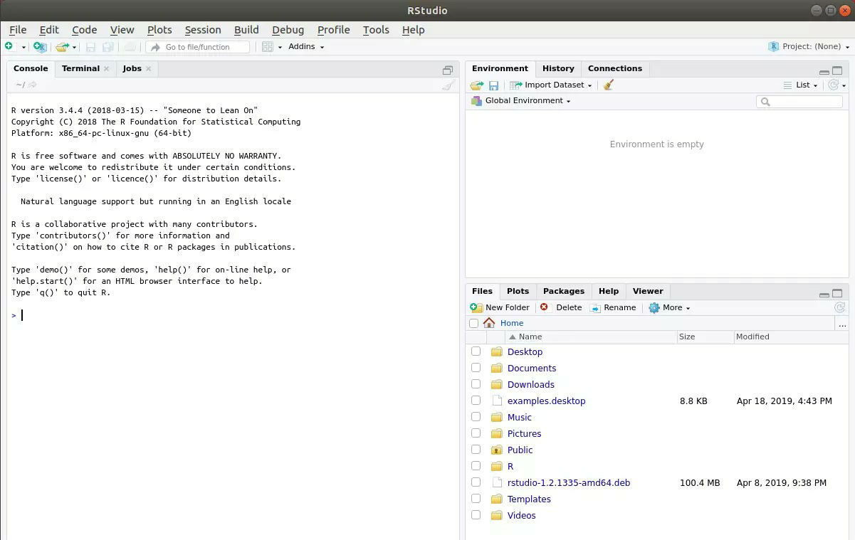

Conclusion – Thus we have studied R and R studio on Ubuntu

# EXPERIMENT NO – 2

Aim- Basic functionality of R - variables, basic arithmetic and help commands.

Theory -

Basic Arithmetic with R—

Below is a script called arithmetic. R . Start R, minimize R-Commander, then go to FILE NEW SCRIPT, opening up a blank script window. Copy the lines below into the script window.

Variables—

You can name variables, vectors, matrices, functions, and subroutines. You are not restricted by the names you use, as long as they are not reserved for existing functions (like the function sum()) in the R package you are using. Remember that R is case sensitive, so the variable x is different from the variable X.

Logical Operators—

R does operations on constants, vectors and matrices logically as well as arithmetically. Following are the examples of logical operators used in R:

1.test=(x<4) Returns true where the condition is satisfied. 2.test=(x==3)

3.test=(x>1 & x<4) AND Operator. 4.test=(x!=4) Not equal to 4. 5.test=(x>1 | x<4) OR Operators.

1. test=(x %in% c(2,4)) Shows whether the number is present in the vector x or not

Visualization in R—

Data visualization is the practice of translating information into a visual context, such as a map or graph, to make data easier for the human brain to understand and pull insights from. The main goal of data visualization is to make it easier to identify patterns, trends and outliers in large datasets. It makes complex data more accessible, understandable, and usable.

Some visualization methods are Scatter Plot, Histogram, Box Plot etc.

A *scatter plot* graphs the actual values in your data against the values predicted by the model. The scatter plot displays the actual values along the X-axis, and displays the predicted values along the Y- axis. It also displays a line that illustrates the perfect prediction, where the predicted value exactly matches the actual value.

The histogram represents the frequency of occurrence of specific phenomena which lie within a specific range of values, which are arranged in consecutive and fixed intervals. The frequency of the data occurrence is represented by a bar, hence it looks very much like a bar graph.

A Box and Whisker Plot (or Box Plot) is a convenient way of visually displaying the data distribution through their quartiles. It is a graphical rendition of statistical data based on the minimum, first quartile, median, third quartile, and maximum. Box plot is used to find the outliers in dataset.

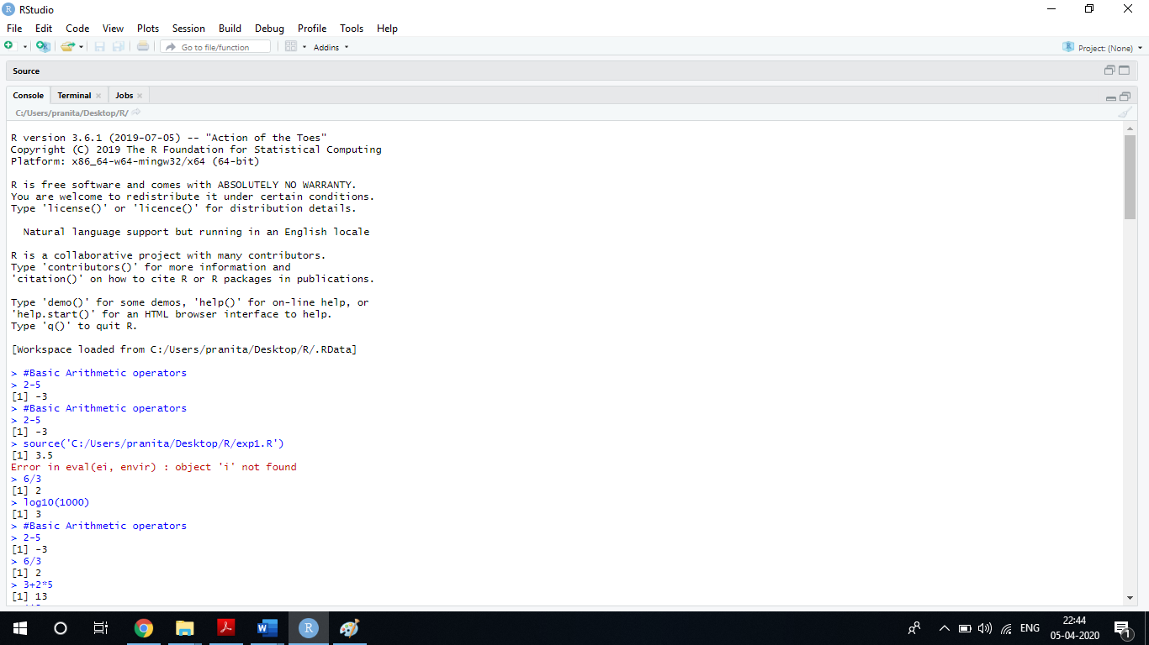

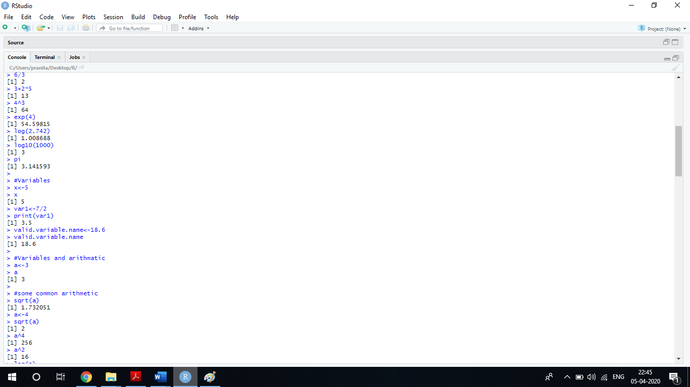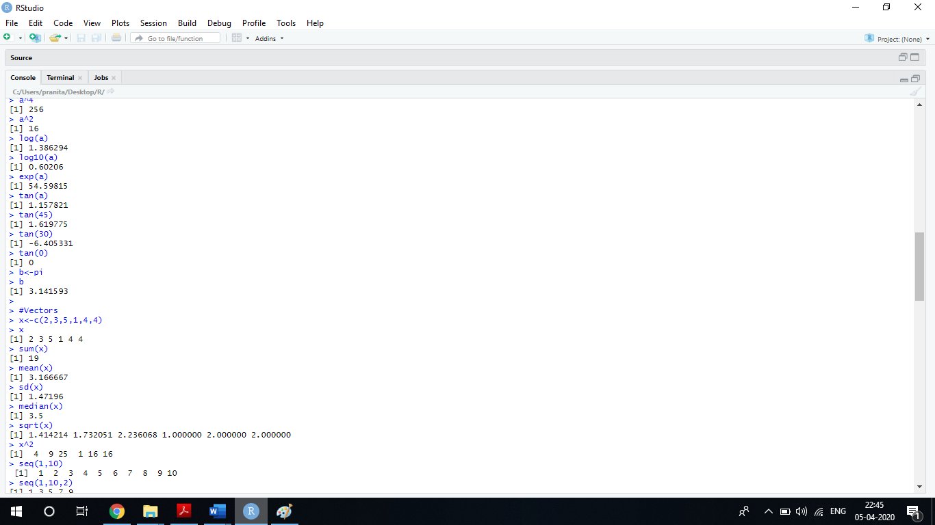

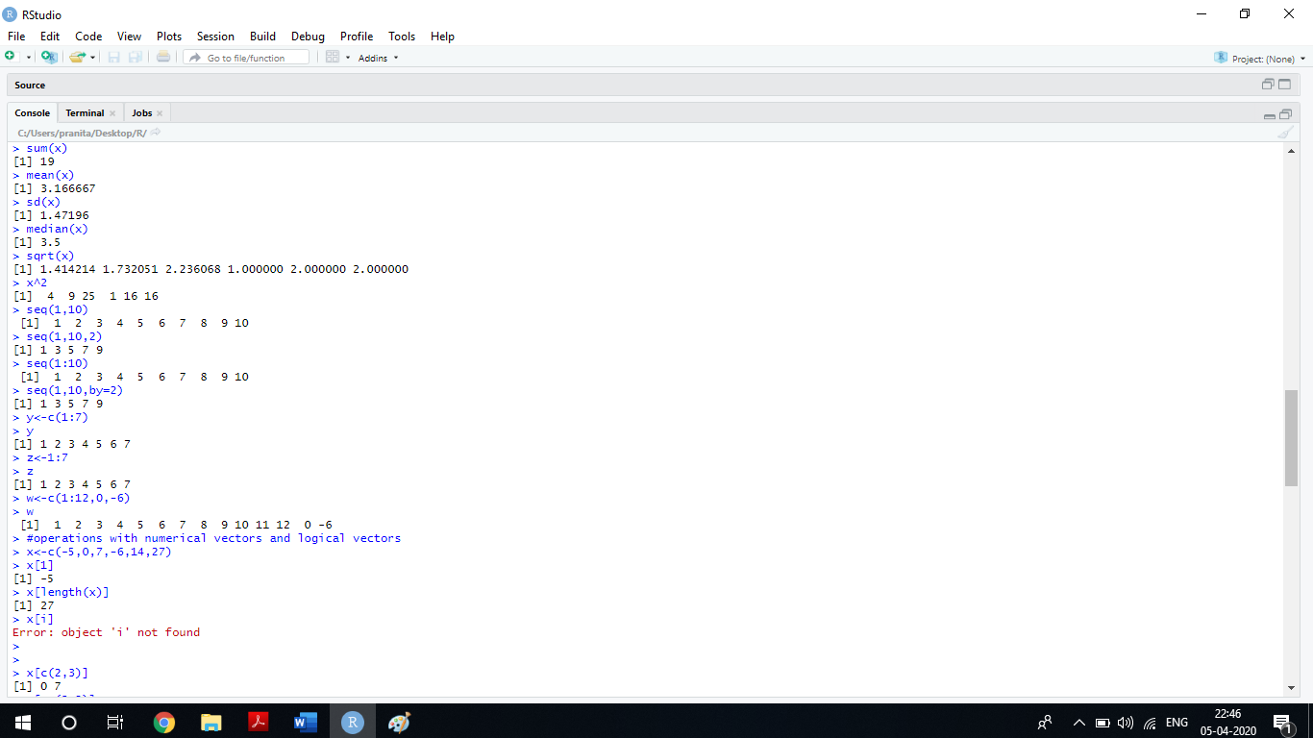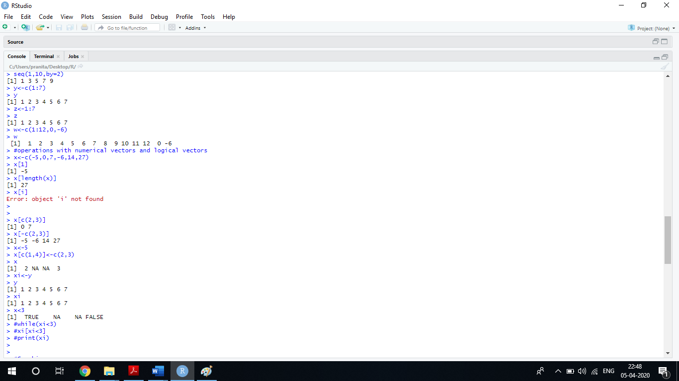

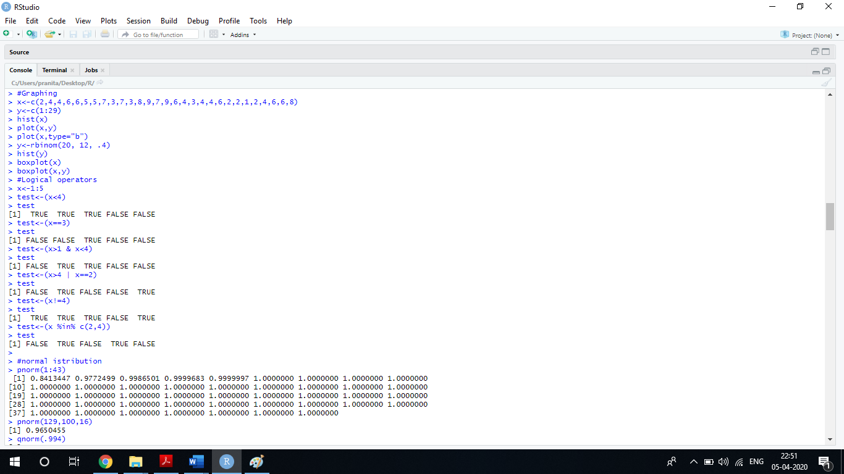

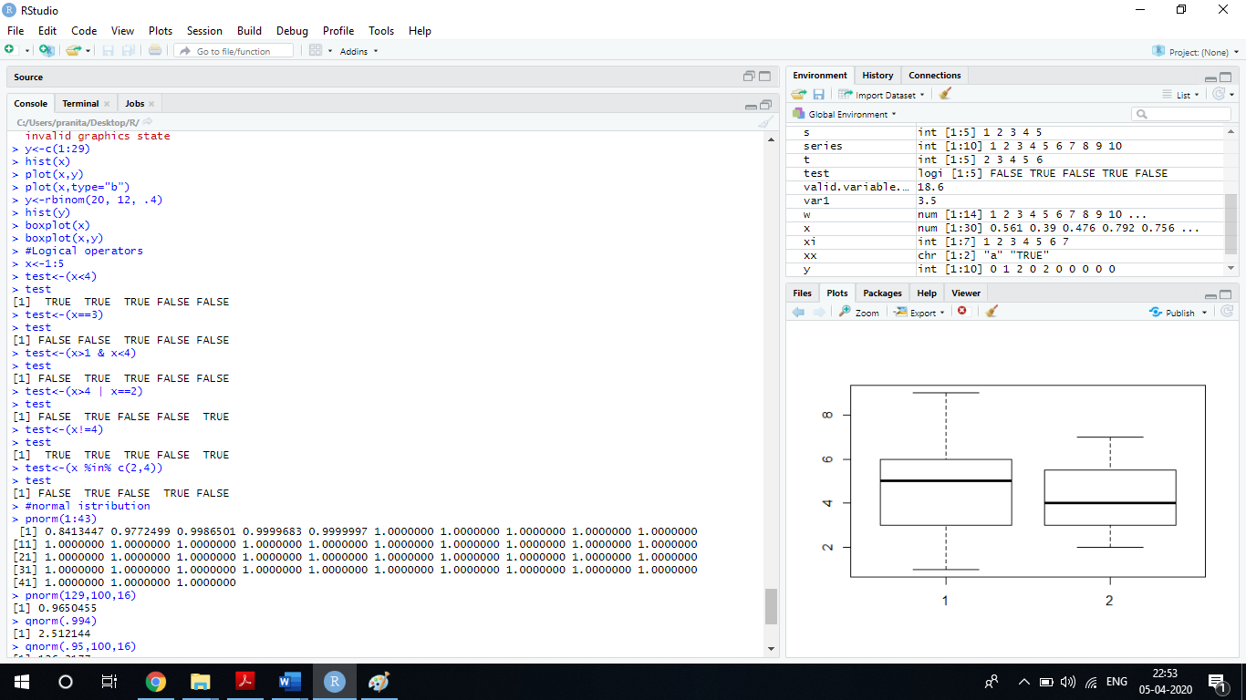

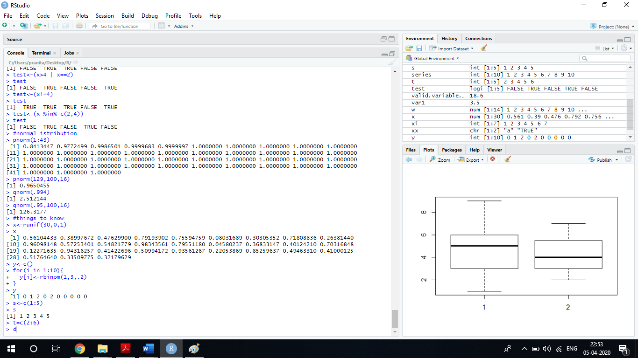

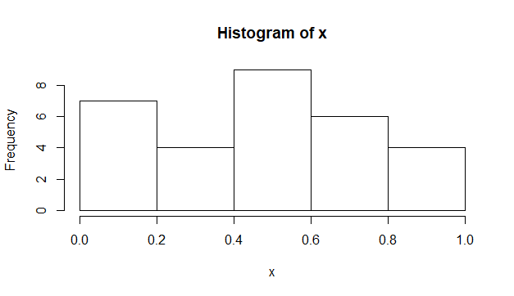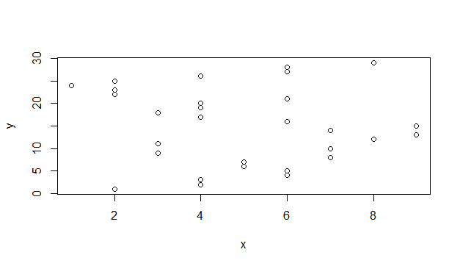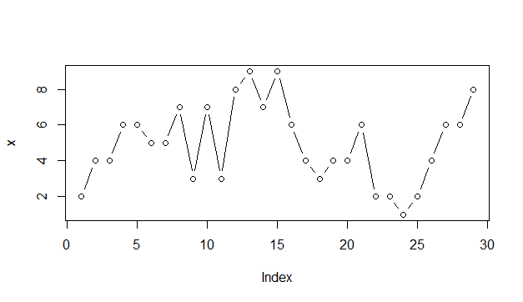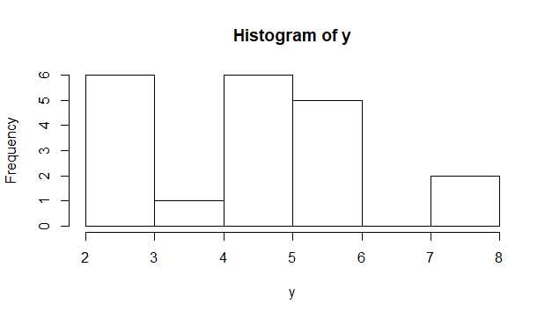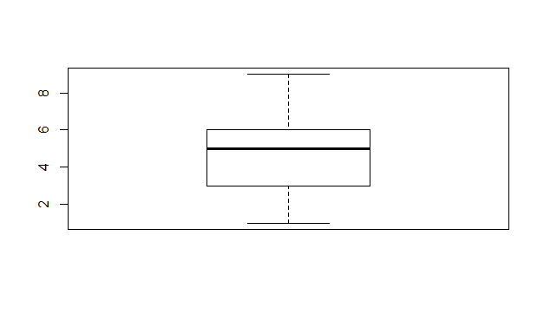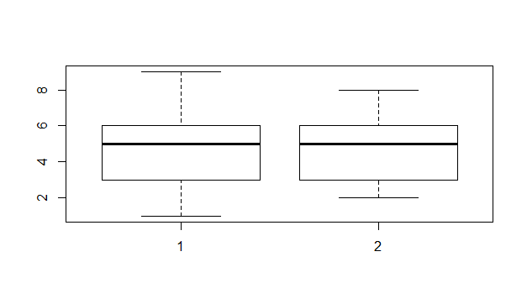

Conclusion – Thus we have studied the basic R commands, functions

# EXPERIMENT NO – 3

Aim - Basic Data types and data structures in R - vector ,matrices,list and dataframes.

Theory –

Vector-

A vector is the most common and basic data structure in R and is pretty much the workhorse of R. Technically, vectors can be one of two types:

* + atomic vectors
  + lists

although the term “vector” most commonly refers to the atomic types not to lists

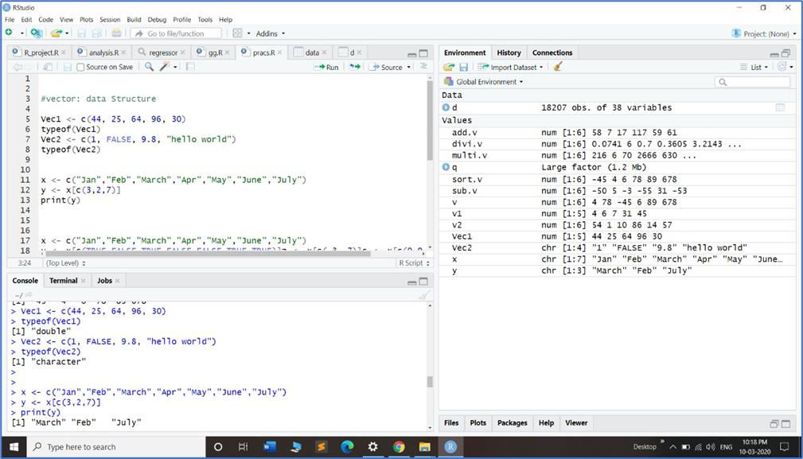

List-

In R lists act as containers. Unlike atomic vectors, the contents of a list are not restricted to a single mode and can encompass any mixture of data types. Lists are sometimes called generic vectors, because the elements of a list can by of any type of R object, even lists containing further lists. This property makes them fundamentally different from atomic vectors.

A list is a special type of vector. Each element can be a different type.

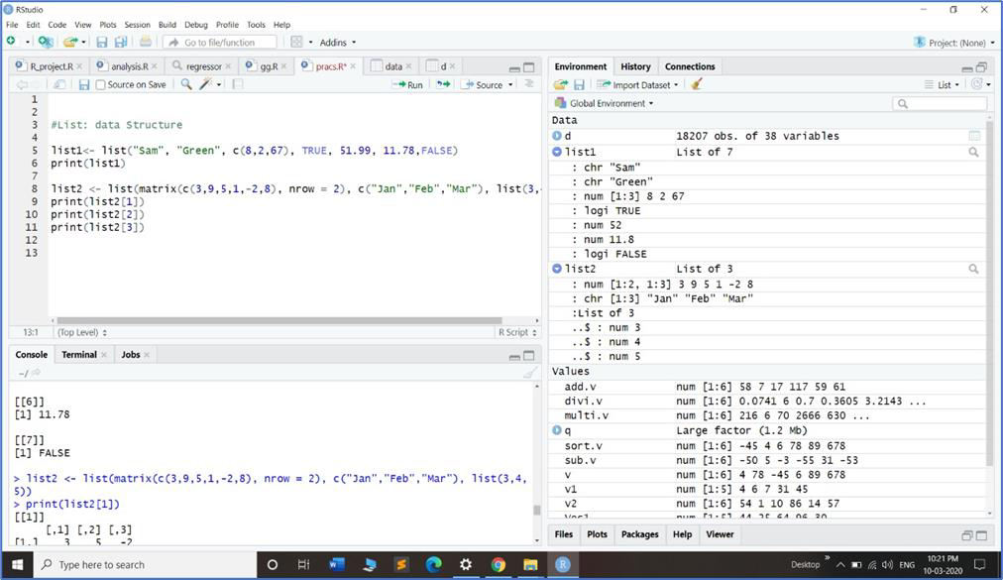

Matrix-

In R matrices are an extension of the numeric or character vectors. They are not a separate type of object but simply an atomic vector with dimensions; the number of rows and columns. As with atomic vectors, the elements of a matrix must be of the same data type

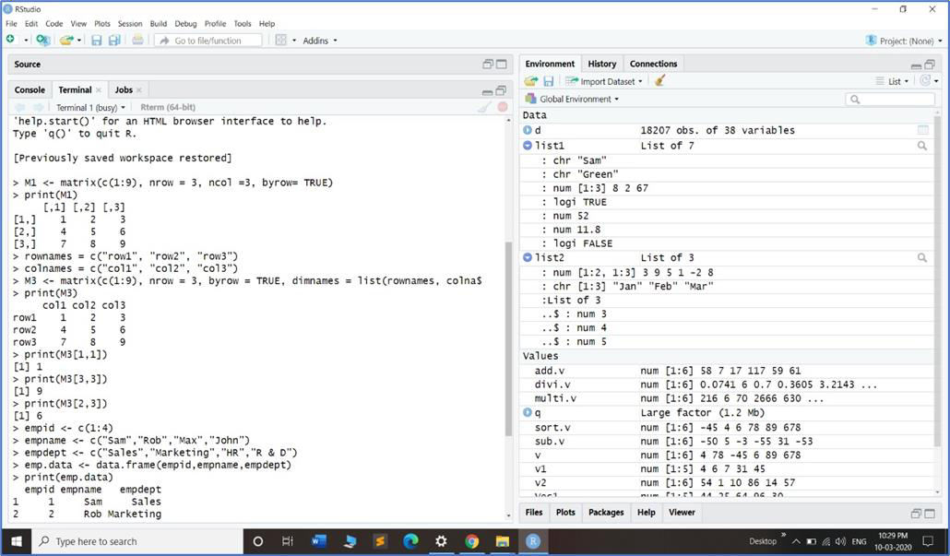

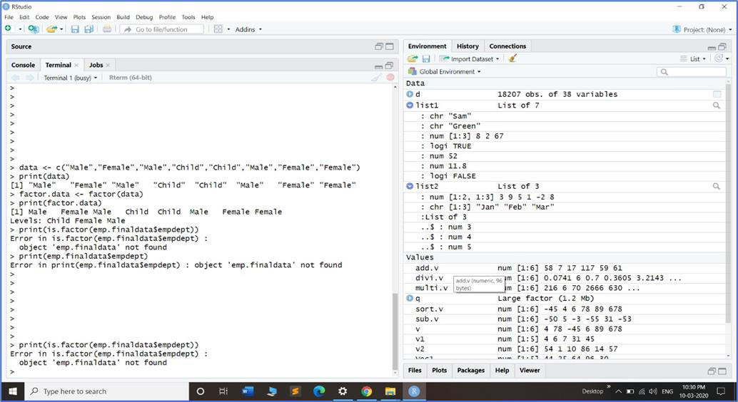

DataFrame

A data frame is a special type of list where every element of the list has same length (i.e. data frame is a “rectangular” list).

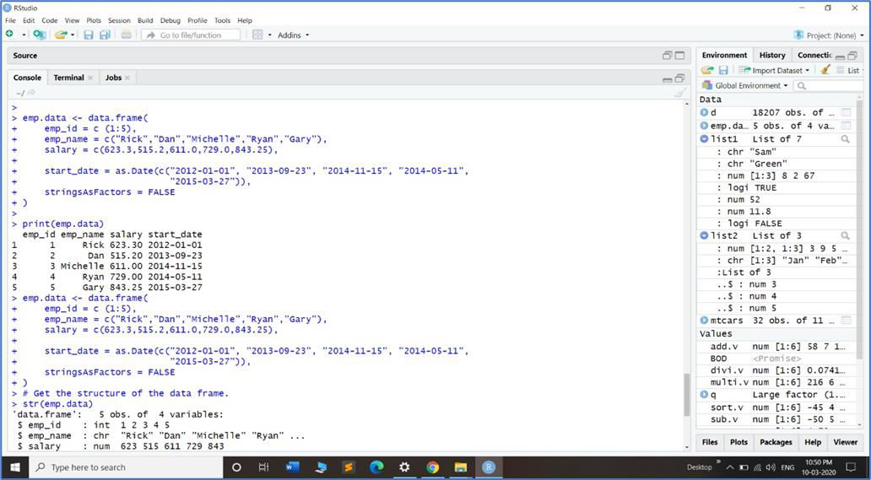

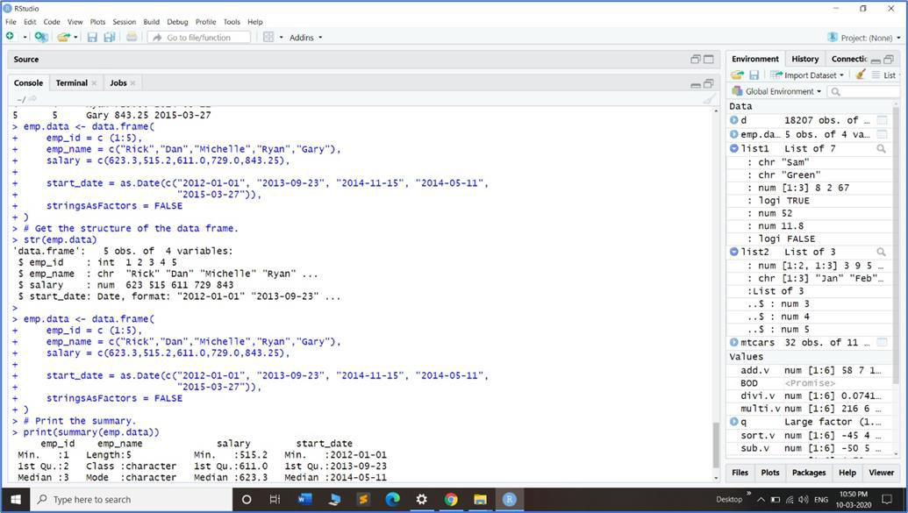

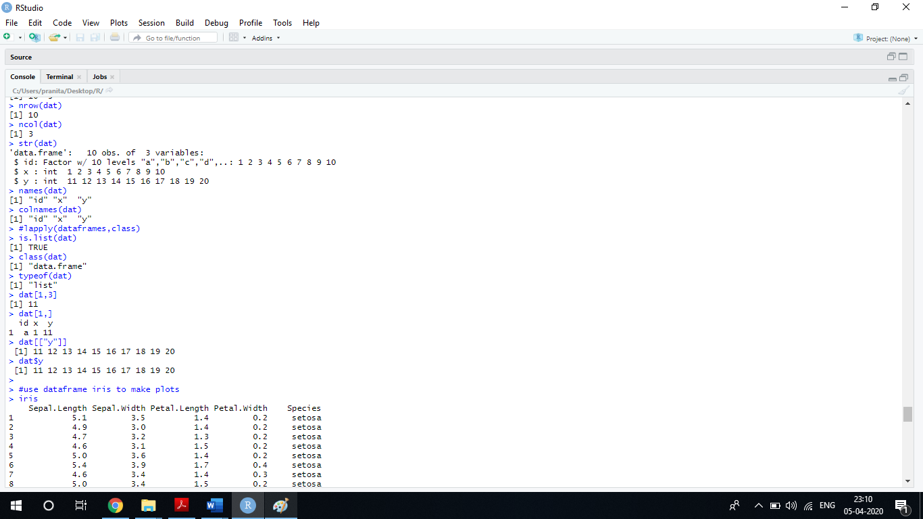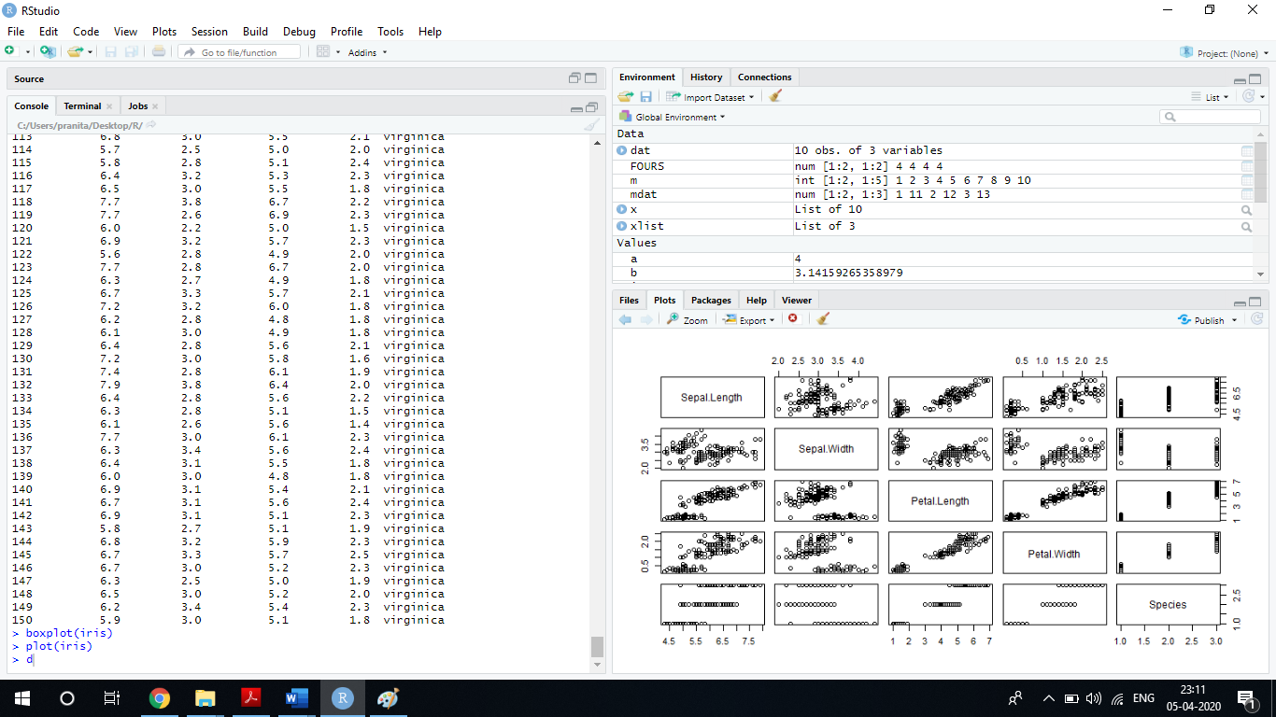

Conclusion **:** Thus, we have studied basic Data types and data structures in R - vector ,matrices, list and dataframes

# EXPERIMENT NO – 4

Aim – Programming constructs in R - loops ,conditional executions Theory-

Grouping Expressions

R is an expression language in the sense that its only command type is a function or expression which returns a result. Even an assignment is an expression whose result is the value assigned, and it may be used wherever any expression may be used; in particular multiple assignments are possible.

Commands may be grouped together in braces, {expr_1; …; expr_m}, in which case the value of the group is the result of the last expression in the group evaluated. Since such a group is also an expression it may, for example, be itself included in parentheses and used as part of an even larger expression, and so on.

Conditional Loops- IF Loop

The “short-circuit” operators && and || are often used as part of the condition in

an if statement. Whereas & and | apply element-wise to vectors, && and || apply to vectors of length one, and only evaluate their second argument if necessary.

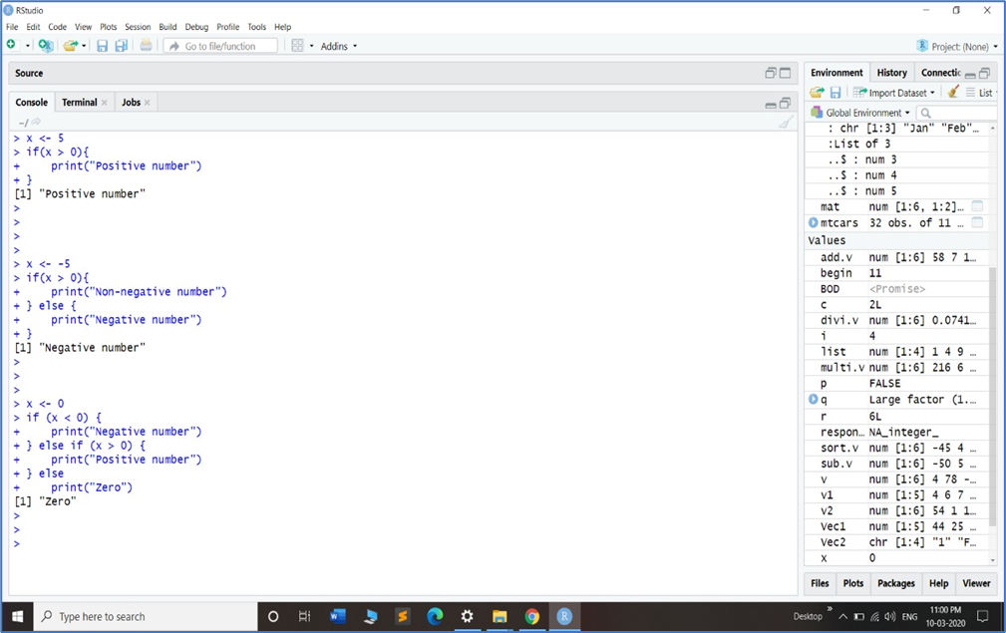

Syntax for For loop:

for (name in expr_1) expr_2

where name is the loop variable. expr_1 is a vector expression, (often a sequence like 1:20), and expr_2 is often a grouped expression with its sub-expressions written in terms of the dummy *name*. expr_2 is repeatedly evaluated as name ranges through the values in the vector result of expr_1.

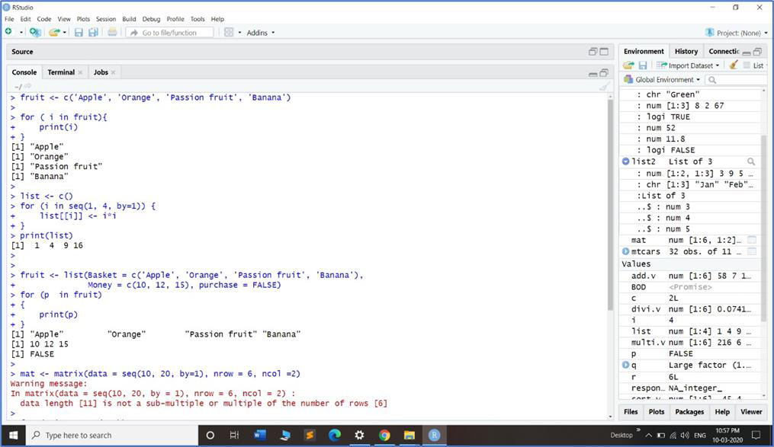

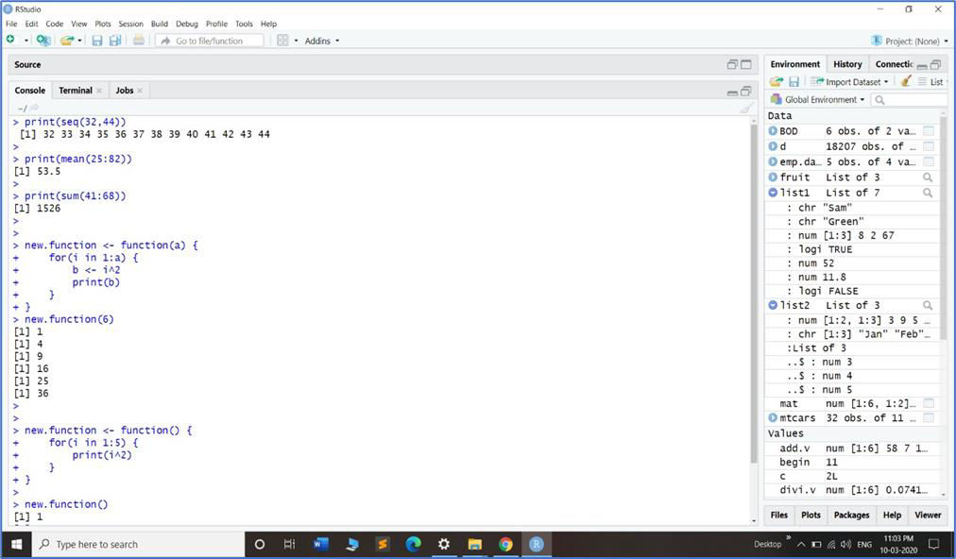

While Loop:

while (condition) expr

The break statement can be used to terminate any loop, possibly abnormally. This is the only way to terminate repeat loops.

The next statement can be used to discontinue one particular cycle and skip to the “next”.

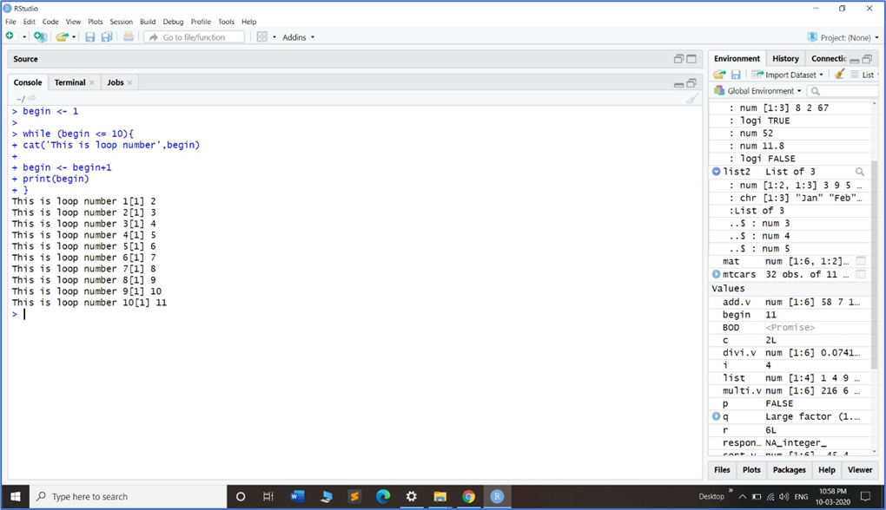

Conclusion **:** Thus we have studied the programming constructs in R.

# EXPERIMENT NO – 5

Aim – Tables with labels in R - multiple response variables excel function translations

Theory –

Cross-tablulation examples

We will use for demonstration well-known mtcars dataset. Let’s start with adding labels to the dataset. Then we can continue with tables creation. For quick cross-tabulation there

are fre and cro family of function. For simplicity we demonstrate here only cro_cpct which calculates column percent. Documentation for other functions, such as cro_cases for counts, cro_rpct for row percent, cro_tpct for table percent and cro_fun for custom summary functions can be seen by typing ?cro and ?cro_fun in the console.

We have more sophisticated interface for table construction with magrittr piping. Table construction consists of at least of three functions chained with pipe operator: %>%. At first we need to specify variables for which statistics will be computed with tab_cells. Secondary, we calculate statistics with one of the tab_stat_* functions. And last, we finalize table creation with tab_pivot, e. g.: dataset

%>% tab_cells(variable) %>% tab_stat_cases() %>% tab_pivot(). After that we can optionally sort table with tab_sort_asc, drop empty rows/columns with drop_rc and transpose with tab_transpose. Resulting table is just a data.frame so we can use usual R operations on it. Detailed documentation for table creation can be seen via ?tables. For significance testing see ?significance. Generally, tables automatically translated to HTML for output in knitr or Jupyter notebooks. However, if we want HTML output in the R notebooks or in the RStudio viewer we need to set options for

that: expss_output_rnotebook() or expss_output_viewer().

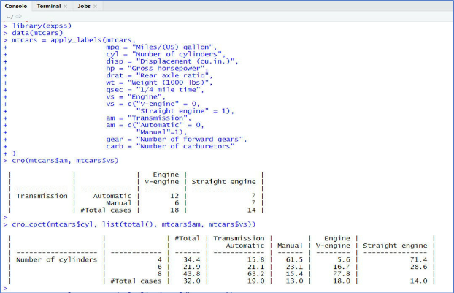

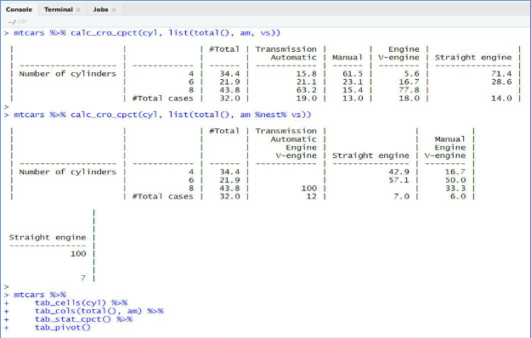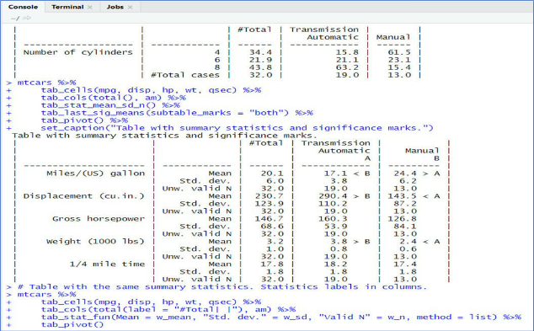

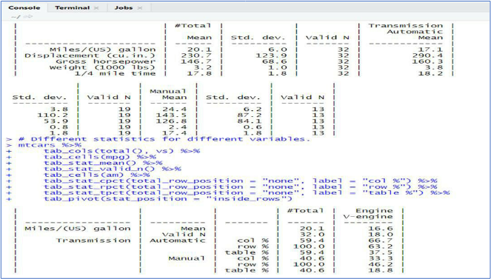

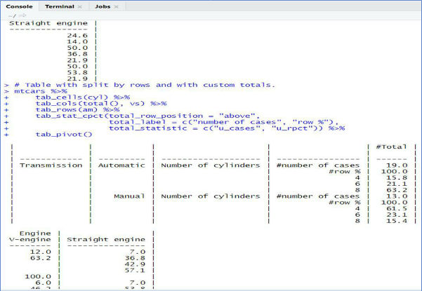

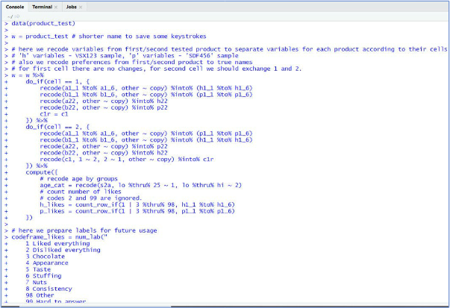

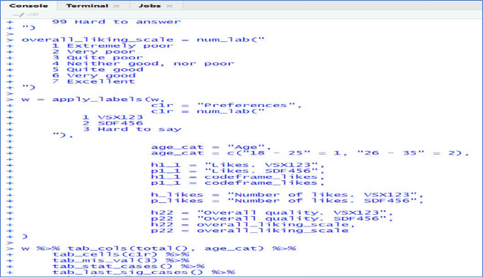

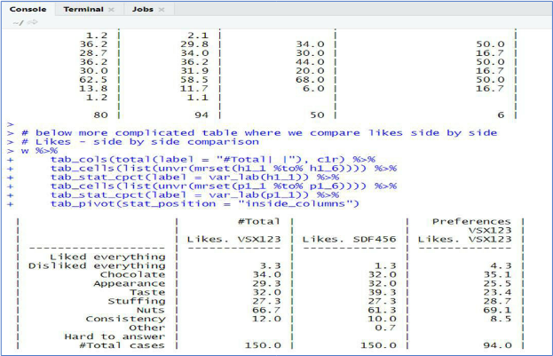

Conclusion**:** Thus, we have studied tables with labels in R.

# EXPERIMENT NO – 6

Aim - Working with large datasets with dplyr and data.table Theory –

Data manipulation operations such as subset, group, update, join etc., are all inherently related. Keeping these related operations together allows for:

* concise and consistent syntax irrespective of the set of operations you would like to perform to achieve your end goal.
* performing analysis fluidly without the cognitive burden of having to map each operation to a particular function from a potentially huge set of functions available before performing the analysis.
* automatically optimising operations internally, and very effectively, by knowing precisely the data required for each operation, leading to very fast and memory efficient code.

data.table is an R package that provides an enhanced version of data.frames, which are the standard data structure for storing data in base R.

dplyr is a grammar of data manipulation, providing a consistent set of verbs that help you solve the most common data manipulation challenges:

* mutate() adds new variables that are functions of existing variables
* select() picks variables based on their names.
* filter() picks cases based on their values.
* summarise() reduces multiple values down to a single summary.
* arrange() changes the ordering of the rows.

These all combine naturally with group_by() which allows you to perform any operation “by group”. dplyr is designed to abstract over how the data is stored. That means as well as working with local data frames, you can also work with remote database tables, using exactly the same R code. Install the dplyr package then read vignette("databases", package = "dbplyr").

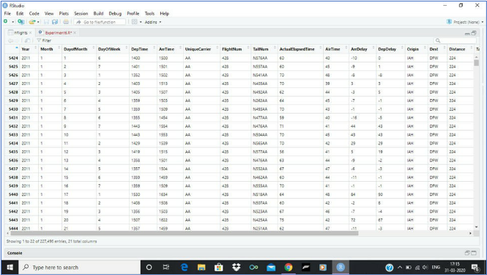

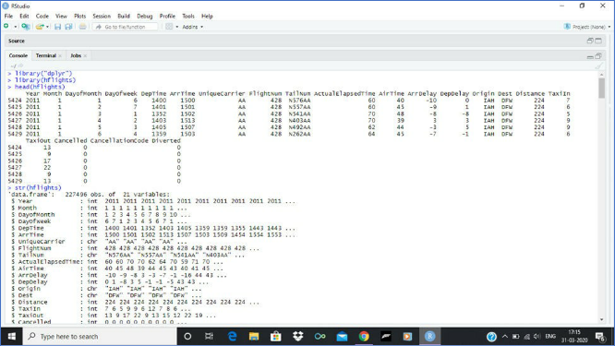

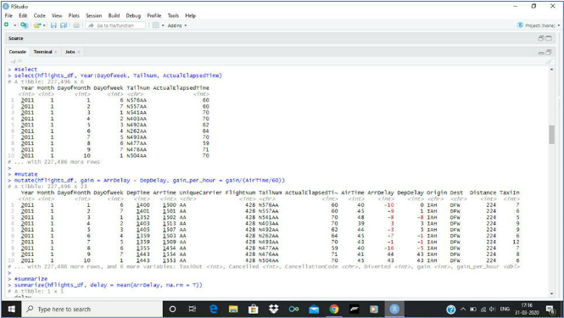

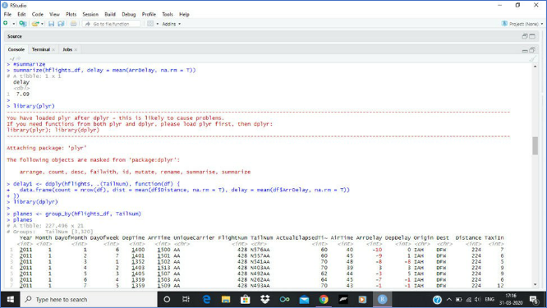

Conclusion **:** Thus, we have studied working with large datasets with dplyr and data.table.

# EXPERIMENT NO – 7

Aim - EDA with R - Range, Summary, Mean, Variance, Median, Standard Deviation, Histogram, Box plot, Scatter Graph

Theory –

A task to use visualisation and transformation to explore your data in a systematic way is known as Exploratory Data Analysis.

Descriptive statistics include:

* + **Mean** - arithmetic average
  + **Median** - middle value
  + **Mode** - most frequent value
  + **Standard Deviation** - variation around the mean
  + **Interquartile Range** - range encompasses 50% of the values
  + **Kurtosis** - peakedness of the data distribution
  + **Skewness** - symmetry of the data distribution Graphical methods include:
  + **Histogram** - a bar plot where each bar represents the frequency of observations for a given range of values
  + **Density estimation** - an estimation of the frequency distribution based on the sample data
  + **Quantile-quantile plot** - a plot of the actual data values against a normal distribution
  + **Box plots** - a visual representation of median, quartiles, symmetry, skewness, and outliers
  + **Scatter plots** - a graphical display of one variable plotted on the x axis and another on the y axis
  + **Radial plots** - plots formatted for the representation of circular data

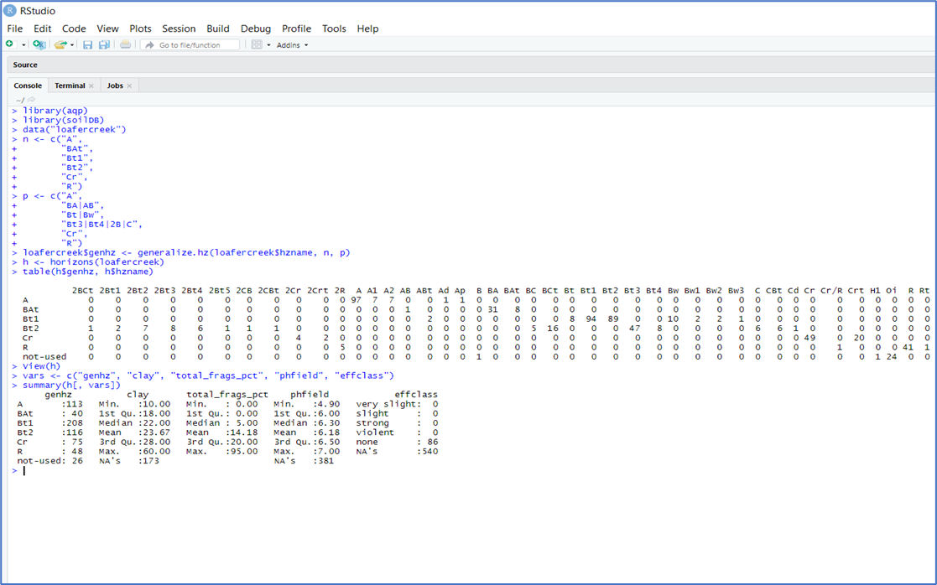

Descriptive Statistics

**Mean** - is the arithmetic average all are familiar with, formally expressed

as: x¯=∑ni=1xinx¯=∑i=1nxin which sums ( ∑∑ ) all the X values in the sample and divides by the number (n) of samples. It is assumed that all references in this document refer to samples rather than a population.

**Median** is the middle measurement of a sample set, and as such is a more robust estimate of central tendency than the mean. This is known as the middle or 50th quantile, meaning there are an equal number of samples with values less than and greater than the median

**Mode** - is the most frequent measurement in the sample. **Variance** is a positive value indicating deviation from the mean **Standard Deviation** is the square root of the variance

**Coefficient of Variation** (CV) is a relative (i.e., unitless) measure of standard deviation

**Quantiles (a.k.a. Percentiles)** - the percentile is the value that cuts off the first nth percent of the data values when sorted in ascending order

**Range** is the difference between the highest and lowest measurement of a group.

**Interquartile Range** (IQR) is the range from the upper (75%) quartile to the lower (25%) quartile. This represents 50% of the observations occurring in the mid-range of a sample. IQR is a robust measure of dispersion, unaffected by the distribution of data.

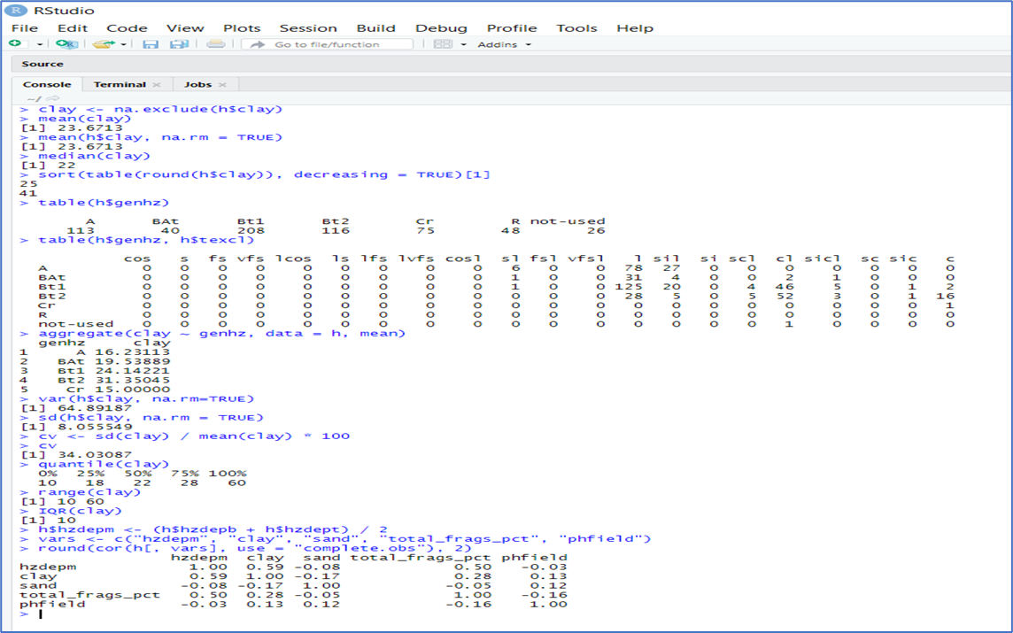

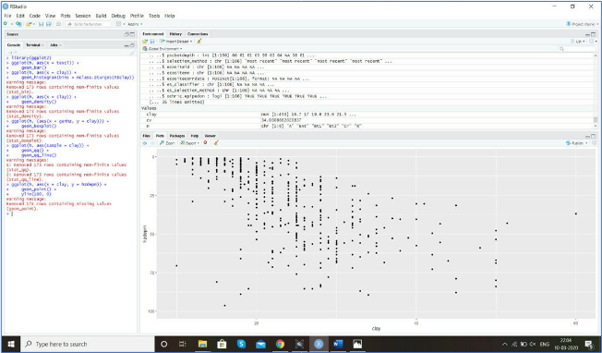

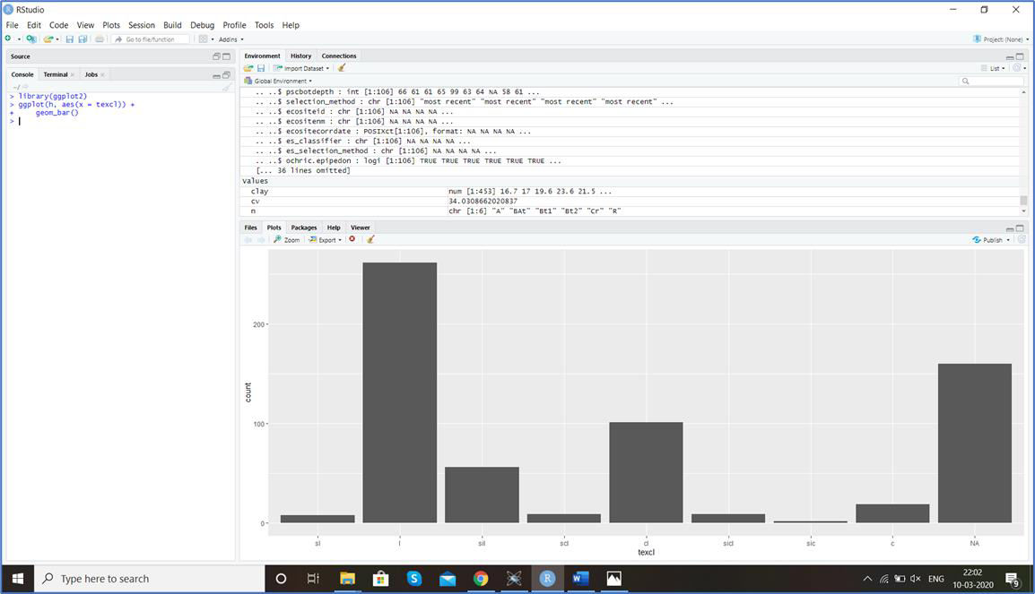

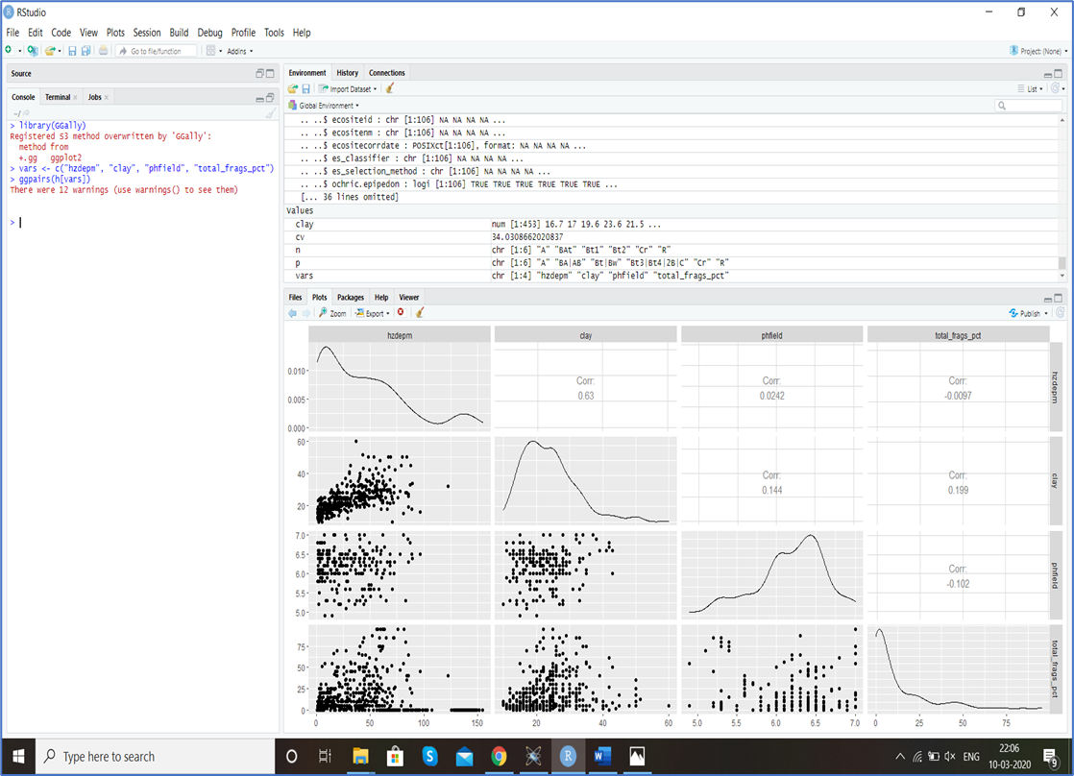

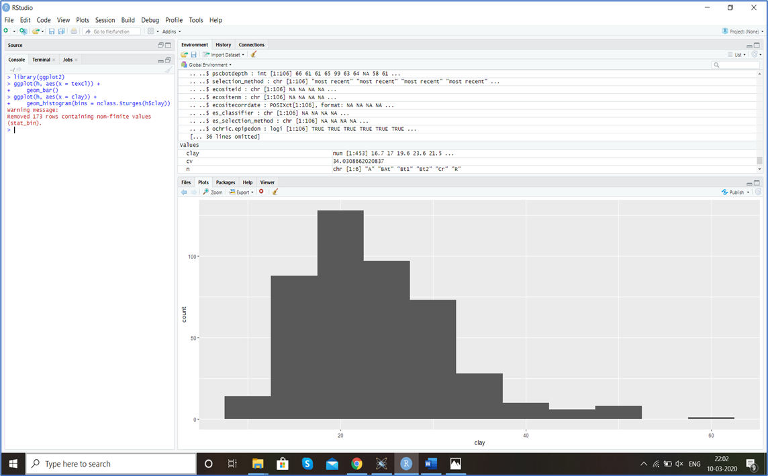

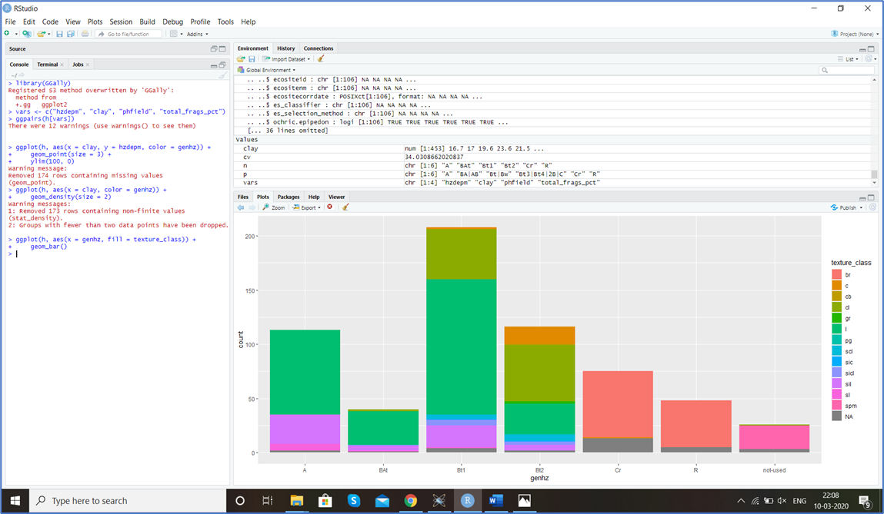

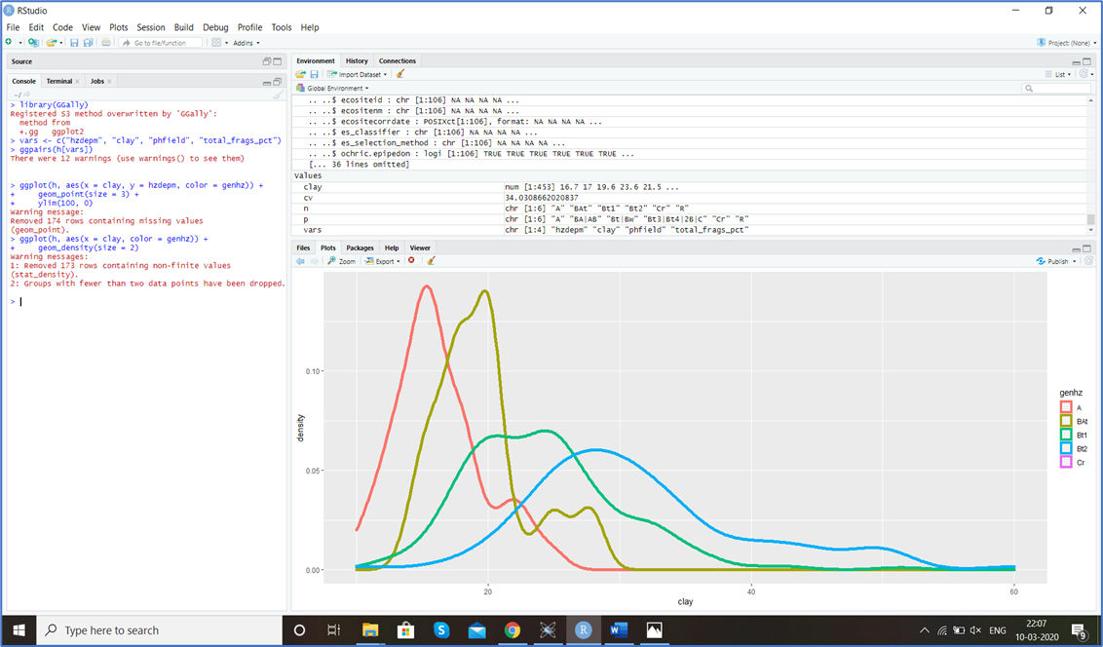

Conclusion - Thus, we have studied EDA in R.

# EXPERIMENT NO – 8

Aim - Basic and Advanced graphics in R

Theory –

The R base function plot() can be used to create graphs. Some of them are :

* **Coplots or Trellised Graphs (library(lattice))** We can create higher level scatterplot matrices using the splom command from the lattice library. The lattice contains numerous functions that allow for the creation of conditional plots or coplots. Conditional plots are basic plots like scatterplots, boxplots, histograms, etc. that are constructed separately for each level of a categorical factor. Some examples of conditional plots are shown below.
* **Panel** The panel option can be used to specify different plot features that can be added to each panel in the trellis display.
* **Box Plot** Box plots are a graphical representation of the five number summary, depicting quartiles (i.e. the 25%, 50%, and 75% quantiles). The parts of the boxplot are shown in the figure below. The “box” of the box plot is defined as the 1st quartile, (Q1 in the figure) and the 3rd quartile, (Q3 in the figure). The median, or 2nd quartile, is the dark line in the box. The whiskers (typically) show data that is 1.5 * IQR above and below the 3rd and 1st quartile.
* **Strip plot** The variance analysis of a strip-plot design is divided into three parts: the horizontal-factor analysis, the vertical-factor analysis, and the interaction analysis.
* **Mores Density Estimates (library(ash))** The ash library contains functions for computing 1- dimensional and 2-dimensional density estimates using the average shifted histograms. Below you will find a couple of examples of their use. The examples use data from study of the differences between genuine and forged Swiss Francs.

Code-

City = read.csv[("h](http://course1.winona.edu/bdeppa/DSCI%20415/Data/City77.csv)tt[p://course1.winona.edu/bdeppa/DSCI%20415/Data/City77.csv](http://course1.winona.edu/bdeppa/DSCI%20415/Data/City77.csv)") # Copy city names to row names, i.e. observation labels

row.names(City) = City$City

# Remove city name column from the data frame City = City[,-1]

names(City)

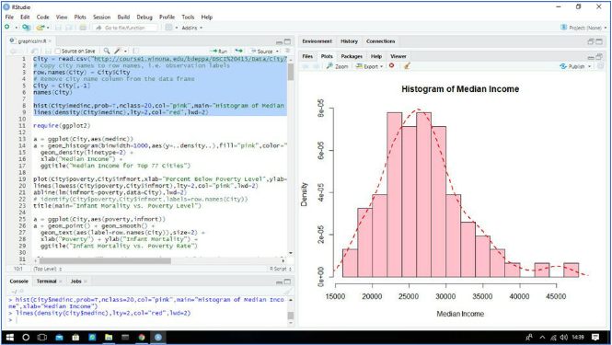

Code –

a = ggplot(City,aes(medinc))

a + geom_histogram(binwidth=1000,aes(y=..density..),fill="pink",color="black") + geom_density(linetype=2) +

xlab("Median Income") +

ggtitle("Median Income for Top 77 Cities")

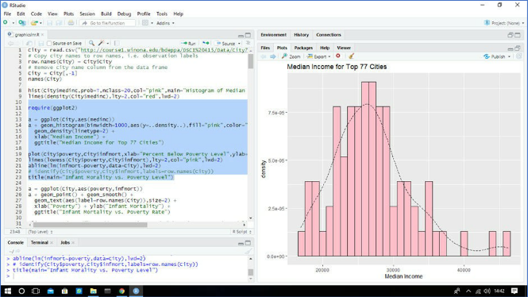

a = ggplot(City,aes(poverty,infmort)) a + geom_point() + geom_smooth() +

geom_text(aes(label=row.names(City)),size=2) + xlab("Poverty") + ylab("Infant Mortality") + ggtitle("Infant Mortality vs. Poverty Rate")

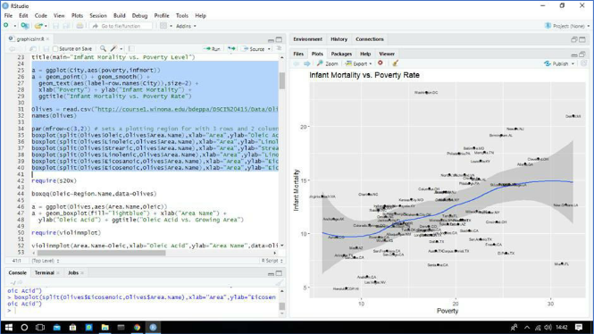

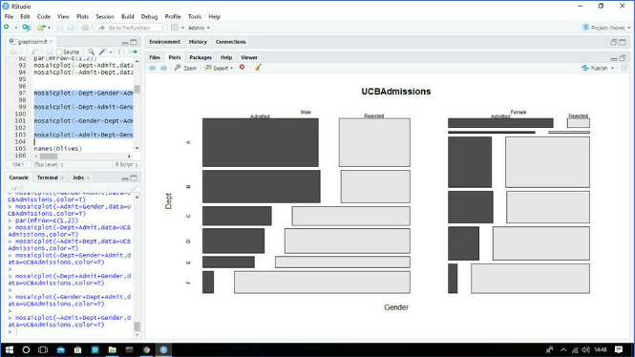

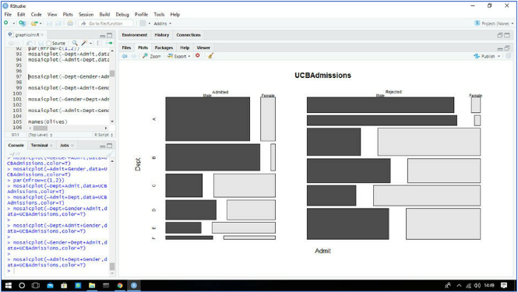

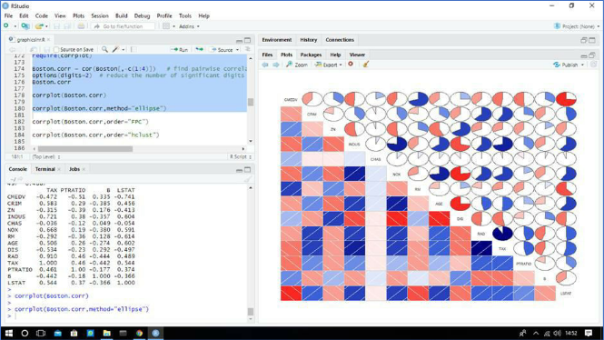

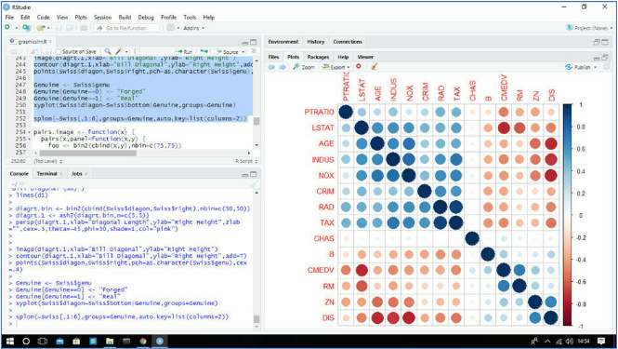

Genuine <- Swiss$genu Genuine[Genuine==0] <- "Forged" Genuine[Genuine==1] <- "Real"

xyplot(Swiss$diagon~Swiss$bottom|Genuine,groups=Genuine)

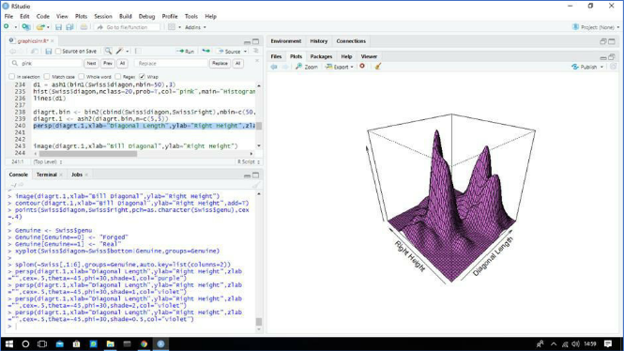

Conclusion **:** Thus we have studied basic and advanced graphics in R.

# EXPERIMENT NO – 9

Aim - Basic of correlation, simple and multiple regression in R

Theory –

# Correlation:

Correlation is a statistical measure that indicates the extent to which two or more [variables](https://whatis.techtarget.com/definition/variable) fluctuate together. A [positive correlation](https://whatis.techtarget.com/definition/positive-correlation) indicates the extent to which those variables increase or decrease in parallel; a [negative correlation](https://whatis.techtarget.com/definition/negative-correlation) indicates the extent to which one variable increases as the other decreases. A [correlation coefficient](https://whatis.techtarget.com/definition/correlation-coefficient) is a statistical measure of the degree to which changes to the value of one variable predict change to the value of another. Correlation Coefficient value ranges from -1 to +1. A perfect [positive correlation](https://www.investopedia.com/terms/p/positive-correlation.asp) means that the correlation coefficient is exactly 1. A perfect [negative correlation](https://www.investopedia.com/terms/n/negative-correlation.asp) means that two assets move in opposite directions, while a zero correlation implies no relationship at all.

**Pearson r correlation:** Pearson *r* correlation is the most widely used correlation statistic to measure the degree of the relationship between linearly related variables. For example, in the stock market, if we want to measure how two stocks are related to each other, Pearson *r* correlation is used to measure the degree of relationship between the two. The point-biserial correlation is conducted with the Pearson correlation formula except that one of the variables is dichotomous. The following formula is used to calculate the Pearson *r* correlation:

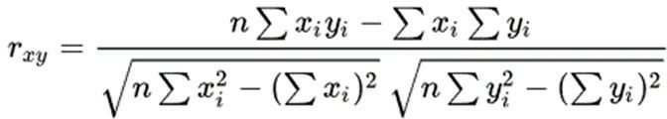

*rxy* = Pearson r correlation coefficient between x and y

*n* = number of observations

*xi* = value of x (for ith observation)

*yi* = value of y (for ith observation)

# Kendall rank correlation:

Kendall rank correlation is a non-parametric test that measures the strength of dependence between two variables. If we consider two samples, a and b, where each sample size is *n*, we know that the total number of pairings with a b is *n*(*n*-1)/2*.* The following formula is used to calculate the value of Kendall rank correlation:

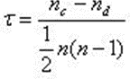

Nc= number of concordant Nd= Number of discordant

# Spearman rank correlation:

Spearman rank correlation is a non-parametric test that is used to measure the degree of association between two variables. The Spearman rank correlation test does not carry any assumptions about the distribution of the data and is the appropriate correlation analysis when the variables are measured on a scale that is at least ordinal.

The following formula is used to calculate the Spearman rank correlation:

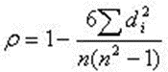

ρ= Spearman rank correlation

di= the difference between the ranks of corresponding variables n= number of observations

Regression:

Regression is a [data mining](https://www.lifewire.com/what-is-data-mining-4784169) technique used to predict a range of numeric values (also

called *continuous values*), given a particular dataset. For example, regression might be used to predict the cost of a product or service, given other variables.Regression is used across multiple industries for business and marketing planning, financial forecasting, environmental modeling and analysis of trends.

Types of Regression:

1. Linear regression:

This technique uses the mathematical formula of a straight line (y = mx + b). In plain terms, this simply means that, given a graph with a Y and an X-axis, the relationship between X and Y is a straight line with few outliers. For example, we might assume that, given an increase in population, food production would increase at the same rate — this requires a strong, linear relationship between the two figures.

1. Multiple regression:

Predicts a relationship between multiple variables — for example, is there a correlation between income, education and where one chooses to live? The addition of more variables considerably increases the complexity of the prediction. There are several types of multiple regression techniques including standard, hierarchical, setwise and stepwise. Types of Multiple Regression:

* + Standard multiple regression
  + Stepwise multiple regression
  + Hierarchical regression
  + Setwise regression

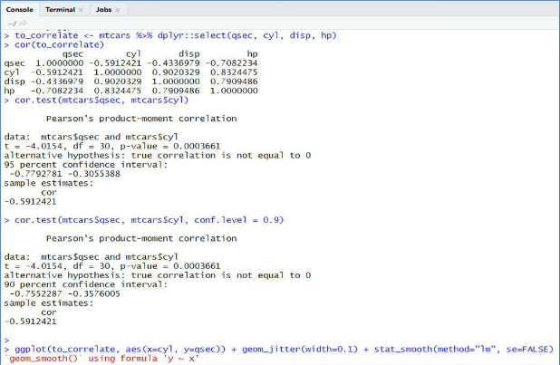

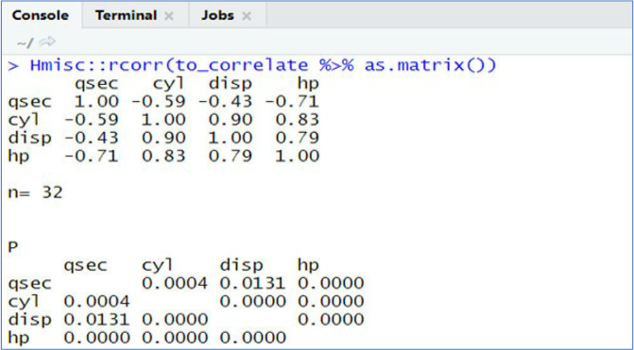

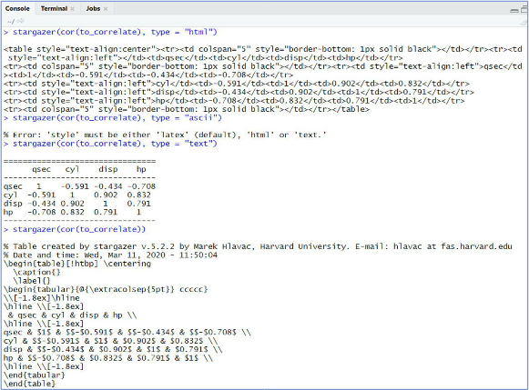

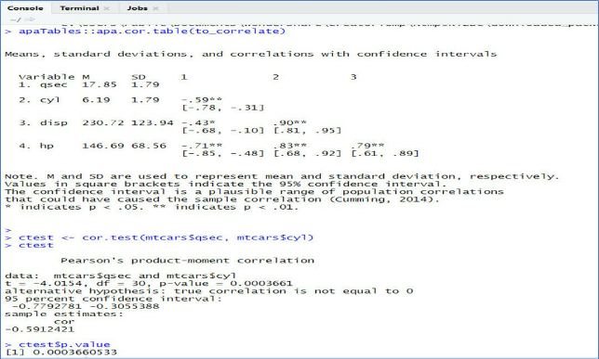

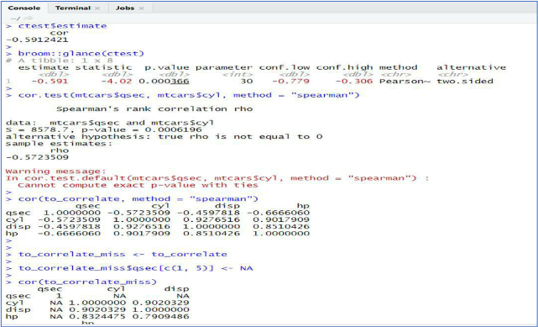

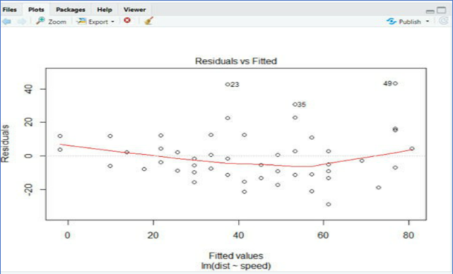

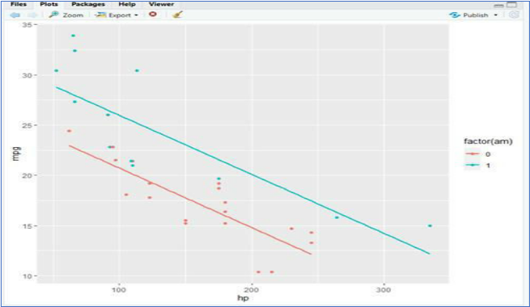

Conclusion - Thus, we have studied the basics of correlation, simple and multiple regression in R.

# EXPERIMENT NO – 10

Aim - Clustering in R - k-means

Theory –

K Means Clustering is an unsupervised learning algorithm that tries to cluster data based on their similarity. Unsupervised learning means that there is no outcome to be predicted, and the algorithm just tries to find patterns in the data. In k means clustering, we have to specify the number of clusters we want the data to be grouped into. The algorithm randomly assigns each observation to a cluster and finds the centroid of each cluster. Then, the algorithm iterates through two steps:

* Reassign data points to the cluster whose centroid is closest.
* Calculate the new centroid of each cluster.

These two steps are repeated until the within-cluster variation cannot be reduced any further. The within-cluster variation is calculated as the sum of the euclidean distance between the data points and their respective cluster centroids.

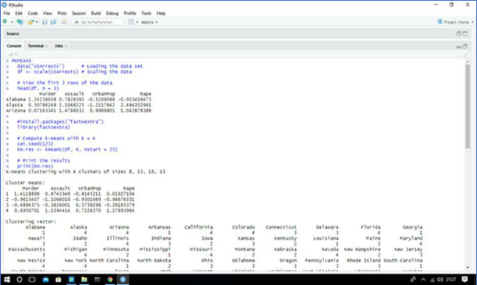

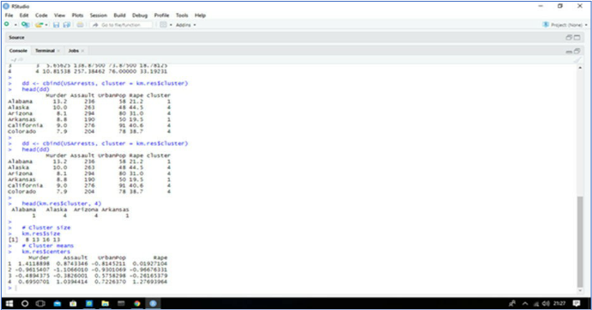

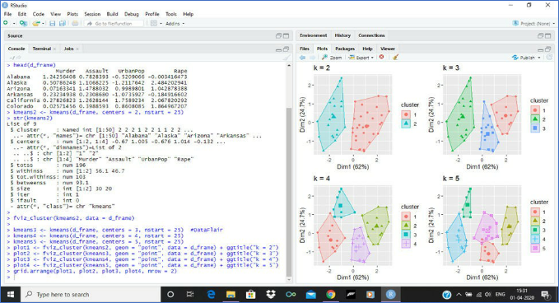

Conclusion **:** This, we have studied clustering in R - k-means

# EXPERIMENT NO – 11

Aim - Classification on large and noisy dataset with R - logistic regression and naive bayes.

Theory –

In statistics, the logistic model (or logit model) is used to model the probability of a certain class or event existing such as pass/fail, win/lose, alive/dead or healthy/sick. This can be extended to model several classes of events such as determining whether an image contains a cat, dog, lion, etc. Each object being detected in the image would be assigned a probability between 0 and 1 and the sum adding to one.

Logistic regression is a statistical model that in its basic form uses a logistic function to model a binary dependent variable, although many more complex extensions exist. In regression analysis, logistic regression (or logit regression) is estimating the parameters of a logistic model (a form of binary regression).

R makes it very easy to fit a logistic regression model. The function to be called is glm() and the fitting process is not so different from the one used in linear regression. In this post I am going to fit a binary logistic regression model and explain each step.

Naïve Bayes classification is a kind of simple probabilistic classification method based on Bayes’ theorem with the assumption of independence between features. The model is trained on a training dataset to make predictions by predict() function. This article introduces two functions naiveBayes() and train() for the performance of Naïve Bayes classification.

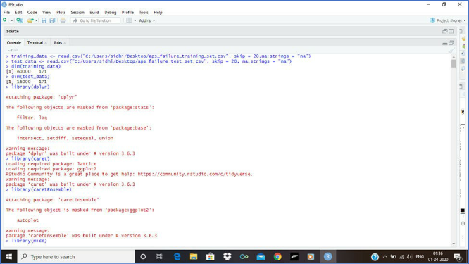

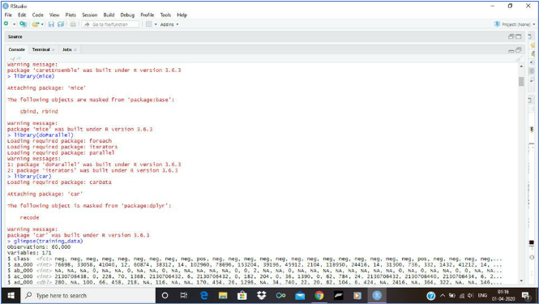

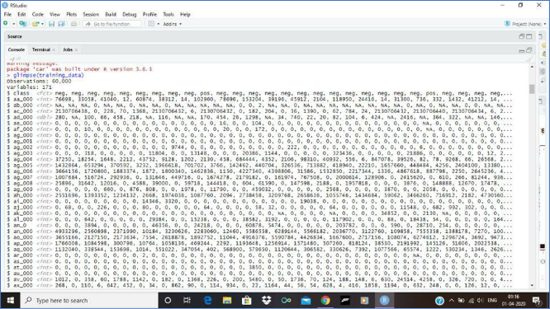

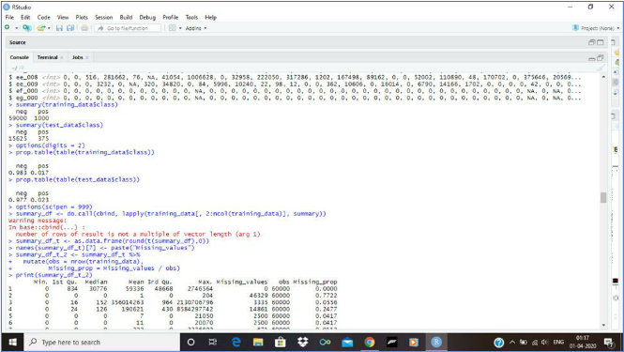

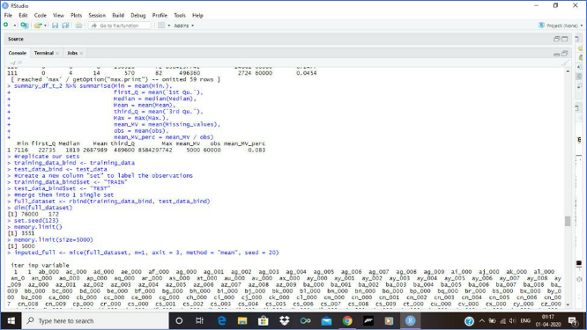

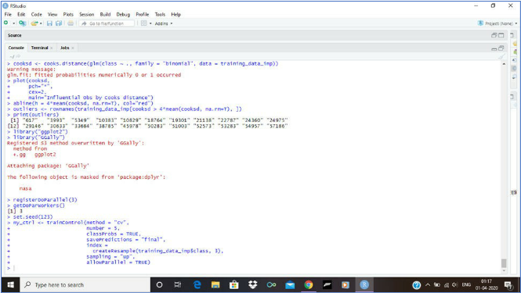

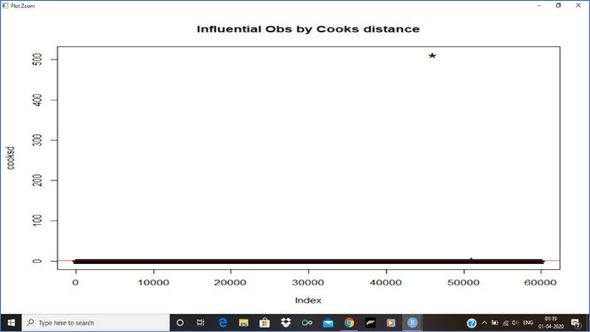

Conclusion - Thus, we have studied classification on large and noisy dataset with R - logistic regression and naive bayes.

**EXPERIMEN NO-12**

**PROJECT NAME: Loan Prediction – Using PCA and Naive Bayes Classification**

**INTRODUCTION:Nowadays, there are numerous risks related to bank loans both for the banks and the borrowers, who get the loans. The risk analysis about bank loans needs understanding about the risk and the risk level. Banks need to analyze their customers for loan eligibility so that they can specifically target those customers.**

**Banks wanted to automate the loan eligibility process (real time) based on customer details such as Gender, Marital Status, Age, Occupation, Income, debts and others, provided in their online application form. As the number of transactions in banking sector is rapidly growing and huge data volumes are available, the customers’ behavior can be easily analyzed and the risks around loan can be reduced. So, it is very important to predict the loan type and loan amount based on the banks’ data.**

**Data Description Customer loan dataset has samples of about 100+ unique customer details, where each customer is represented in a unique row.**

**DATASET:**

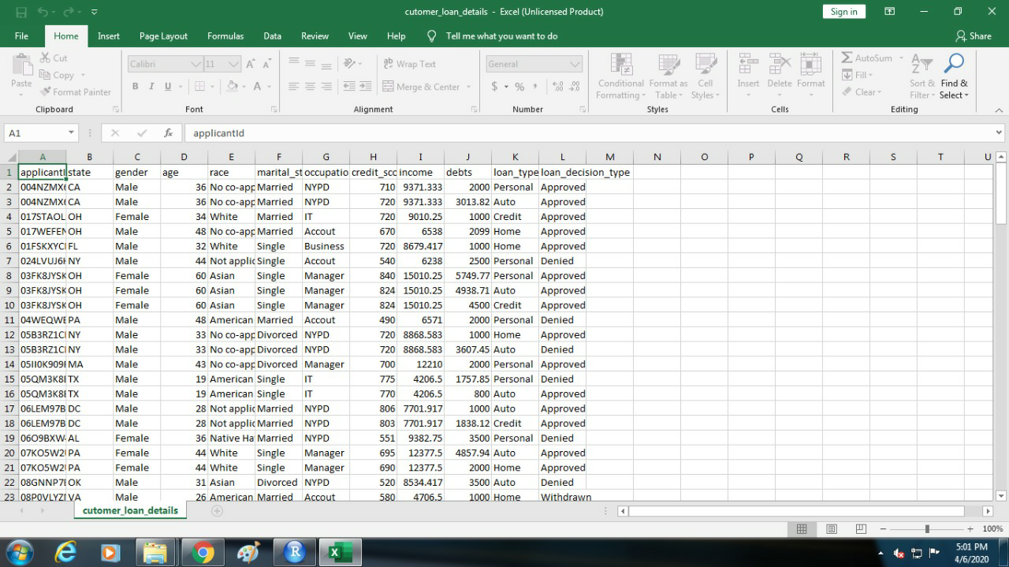

**Code:**

**customer_loan_details <- read.csv("D:/cutomer_loan_details.csv", sep = ",")**

**str(customer_loan_details)**

**head(customer_loan_details)**

**any(is.na(customer_loan_details))**

**customer_loan_details$dti <- (customer_loan_details$debts/customer_loan_details$income)*100**

**customer_loan_details$loan_decision_status <- ifelse(customer_loan_details$loan_decision_type == 'Denied', 0, 1)**

**customer_loan_details$loan_decision_status <- factor(customer_loan_details$loan_decision_status, levels = c(0, 1))**

**customer_loan_refined <- customer_loan_details[,c(3,4,6:8,11,13:14)]**

**head(customer_loan_refined)**

**customer_loan_refined$gender <- as.numeric(factor(customer_loan_refined$gender,**

**levels = c('Male','Female'),**

**labels = c(1,2)))**

**customer_loan_refined$marital_status <- as.numeric(factor(customer_loan_refined$marital_status,**

**levels = c('Divorced','Married','Single'),**

**labels = c(1,2,3)))**

**customer_loan_refined$occupation <- as.numeric(factor(customer_loan_refined$occupation,**

**levels = c('Accout','Business','IT','Manager','NYPD'),**

**labels = c(1,2,3,4,5)))**

**customer_loan_refined$loan_type <- as.numeric(factor(customer_loan_refined$loan_type,**

**levels = c('Auto','Credit','Home','Personal'),**

**labels = c(1,2,3,4)))**

**head(customer_loan_refined)**

**library(caTools)**

**set.seed(123)**

**split = sample.split(customer_loan_refined$loan_decision_status, SplitRatio = 0.70)**

**training_set = subset(customer_loan_refined, split == TRUE)**

**test_set = subset(customer_loan_refined, split == FALSE)**

**training_set[-8] = scale(training_set[-8])**

**test_set[-8] = scale(test_set[-8])**

**head(training_set)**

**# install.packages("caret")**

**library(caret)**

**pca = preProcess(x = training_set[-8], method = 'pca', pcaComp = 2)**

**training_set_pca = predict(pca, training_set)**

**training_set_pca = training_set_pca[c(2, 3, 1)]**

**test_set_pca = predict(pca, test_set)**

**test_set_pca = test_set_pca[c(2, 3, 1)]**

**head(test_set_pca)**

**# install.packages("e1071")**

**library(e1071)**

**classifier = naiveBayes(x = training_set_pca[-3], y = training_set_pca$loan_decision_status)**

**y_pred = predict(classifier, newdata = test_set_pca[-3])**

**confusionMatrix(table(test_set_pca[, 3], y_pred))**

**# install.packages("ElemStatLearn")**

**library(ElemStatLearn)**

**set = test_set_pca**

**# Built the grid using X1, X2 by taking min-1 and max+1 values from test set**

**X1 = seq(min(set[, 1]) - 1, max(set[, 1]) + 1, by = 0.01)**

**X2 = seq(min(set[, 2]) - 1, max(set[, 2]) + 1, by = 0.01)**

**grid_set = expand.grid(X1, X2)**

**colnames(grid_set) = c('PC1', 'PC2')**

**# Predict the test set observations**

**y_grid = predict(classifier, newdata = grid_set)**

**plot(set[, -3], main = 'Naive Bayes (Test set)',**

**xlab = 'PC1', ylab = 'PC2',**

**xlim = range(X1), ylim = range(X2))**

**contour(X1, X2, matrix(as.numeric(y_grid), length(X1), length(X2)), add = TRUE)**

**points(grid_set, pch = '.', col = ifelse(y_grid == 1, 'springgreen3', 'tomato'))**

**points(set, pch = 21, bg = ifelse(set[, 3] == 1, 'green4', 'red3'))**

* **Import Libraries**

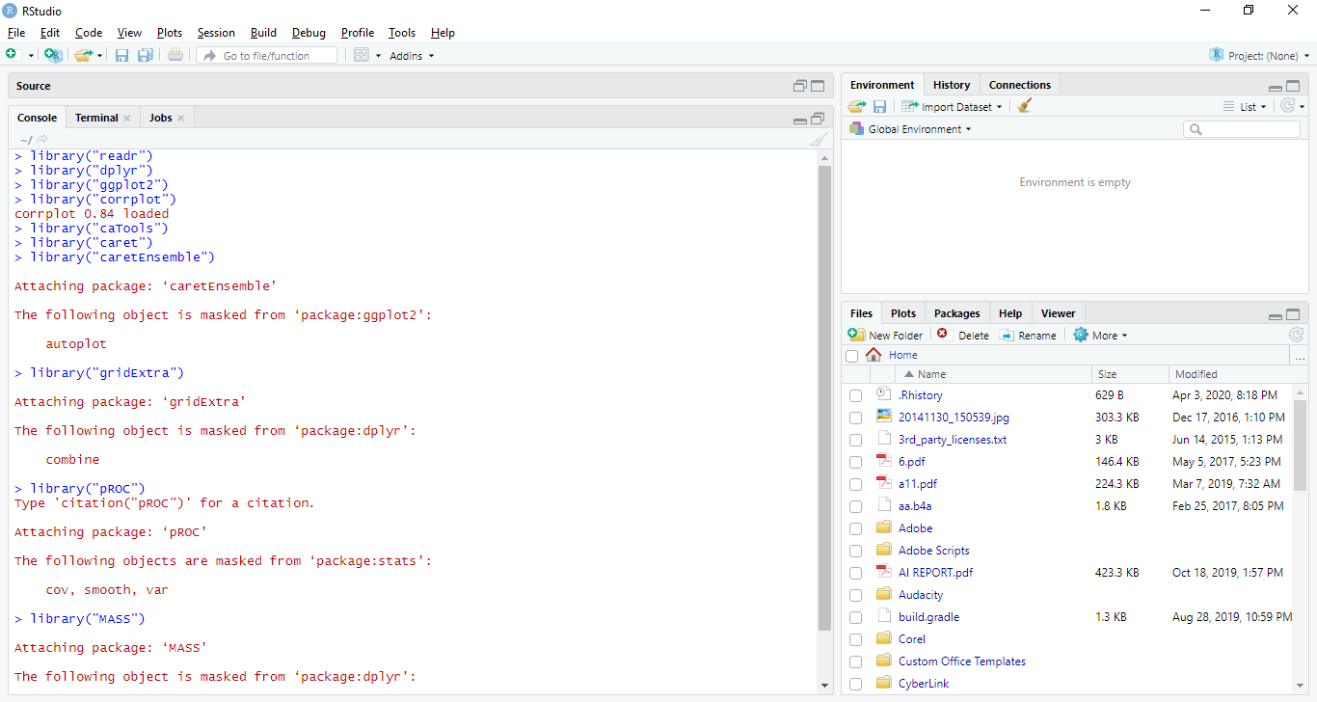

* **Import Dataset**

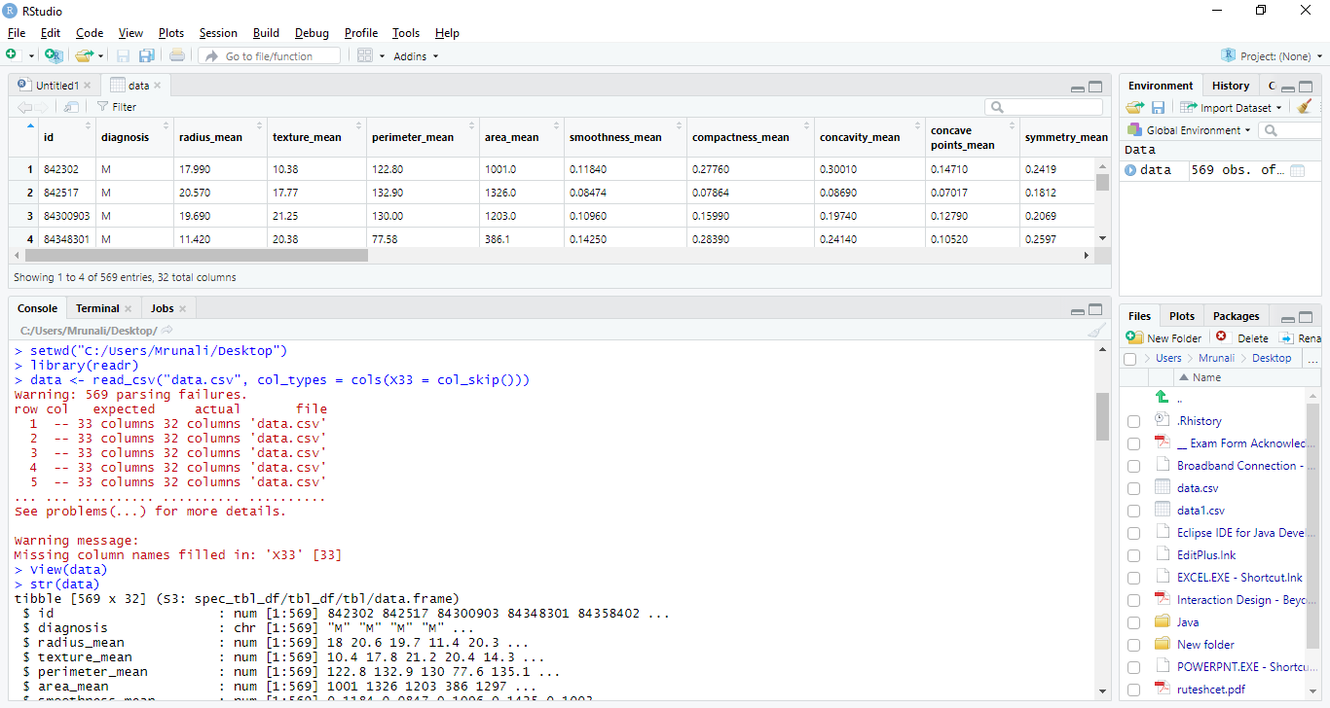

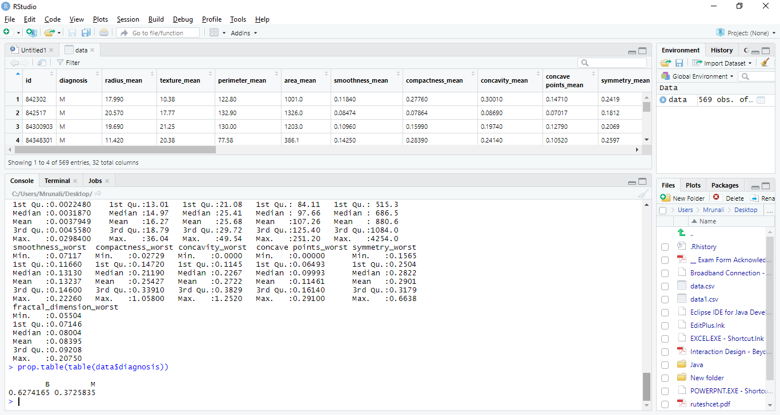

## Naive Bayes Classification output:

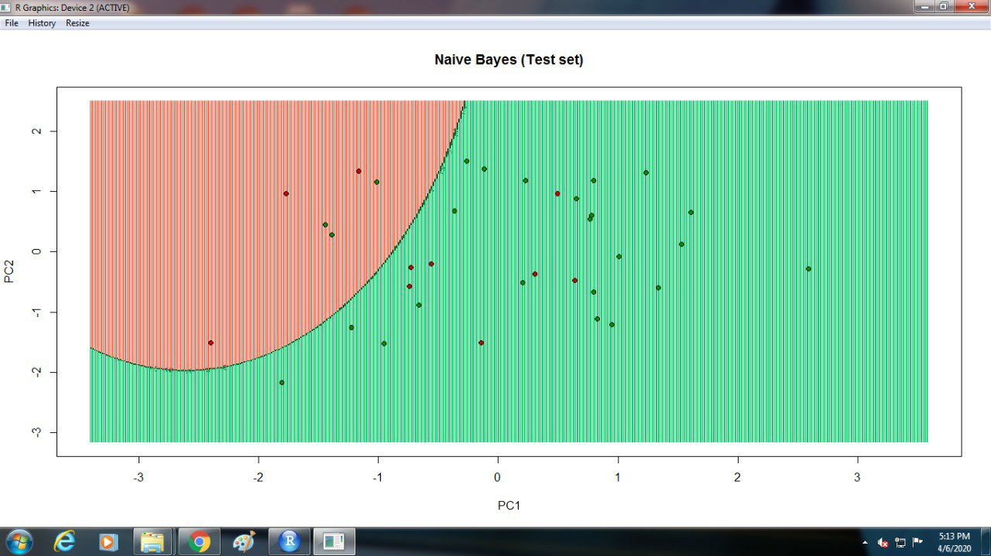

* **Correlation**

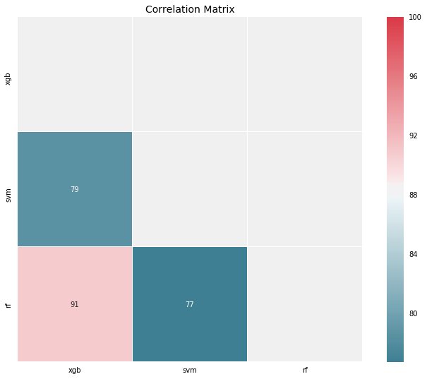

* Confusion matrix

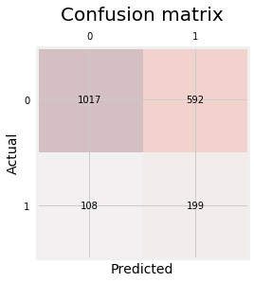

* **Decision Tree**

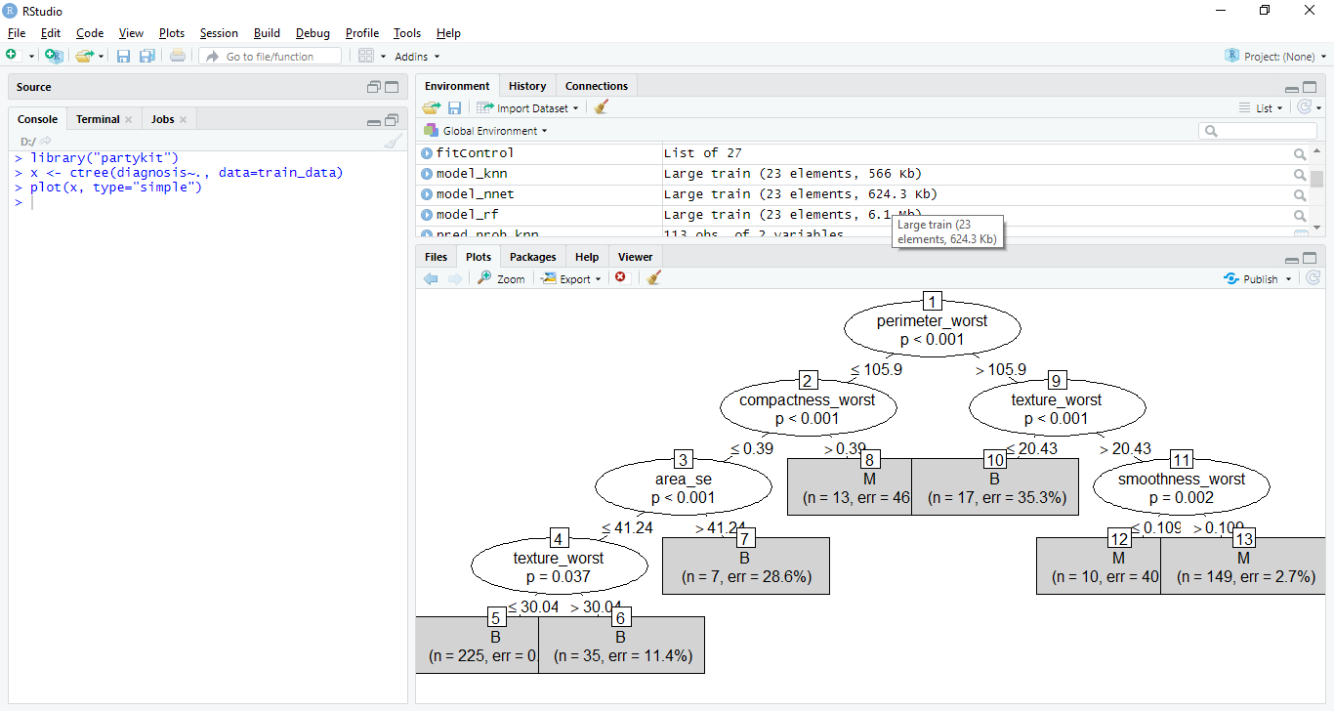

**Conclusion:**

**There is no definitive guide of which algorithms to use given any situation. What may work on some data sets may not necessarily work on others. Therefore, always evaluate methods using cross validation to get a reliable estimates.**

### 